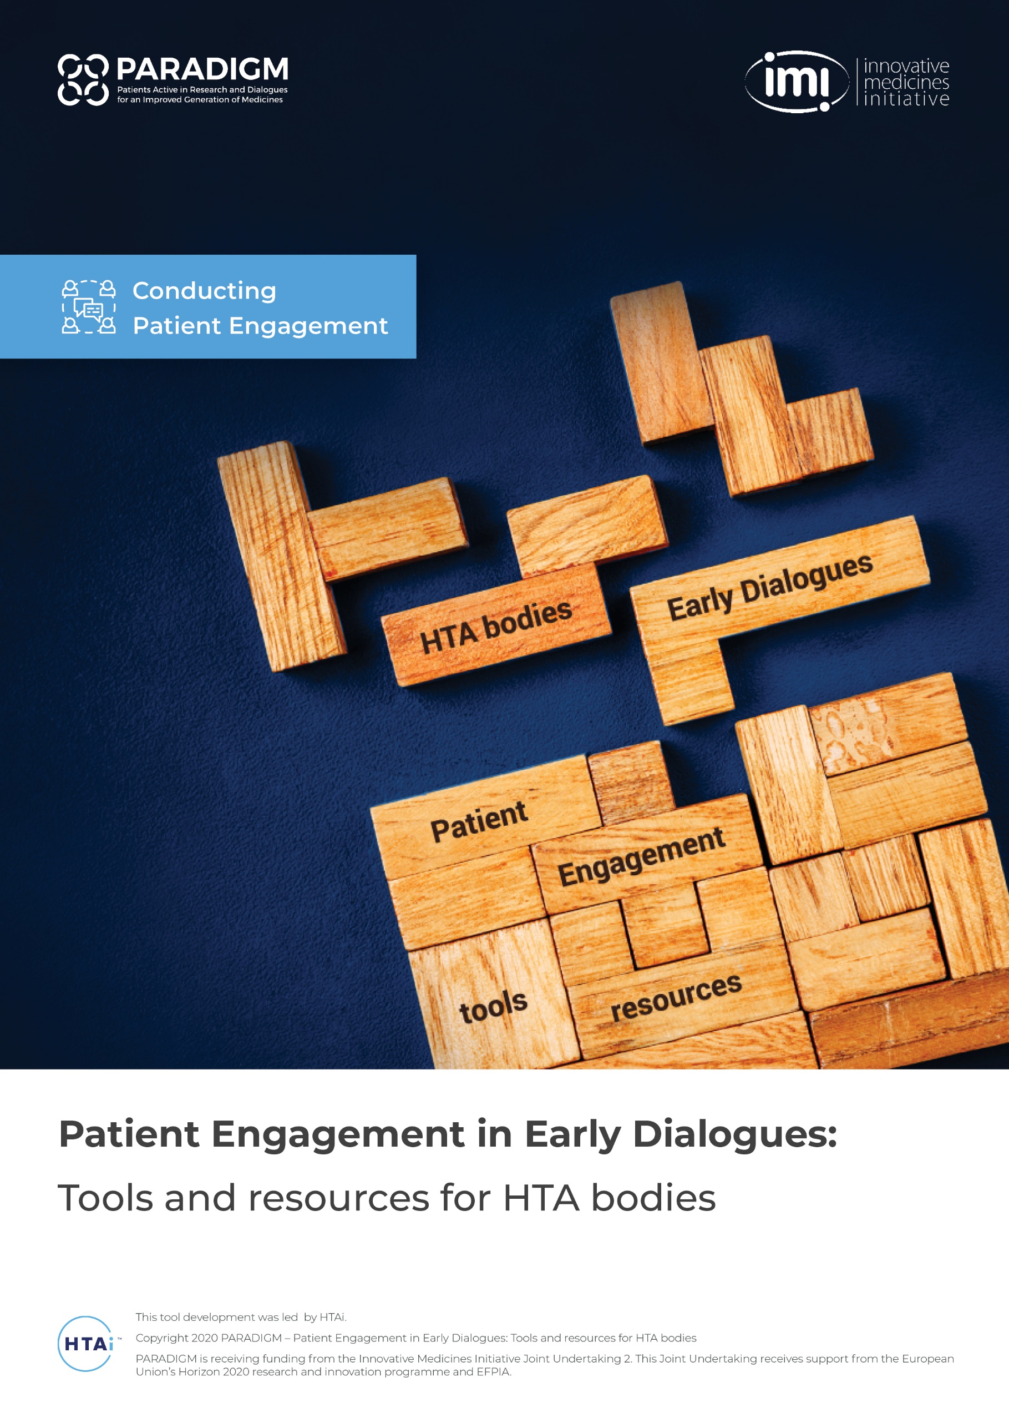

CONTENTS
INTRODUCTION 4
About Early Dialogues 4
What is this toolkit? 4
Structure of this resource 5
Format of these tools 5
How these tools were developed 5
SECTION 1: The Rationale for engaging patients in Early Dialogues 7
Fact Sheet: What are Early Dialogues? 8
Fact Sheet: Why take part in an Early Dialogue? (for patients) 11
Fact Sheet: Why engage patients in Early Dialogues? (for HTA bodies) 15
Vignettes: Examples of patient engagement in Early Dialogues 18
Template: A blank template for use to collect further examples 18
SECTION 2: Guidance on the methods of patient engagement in Early Dialogues 22
Fact Sheet: Overview of main processes and methods 23
Guidance: Considerations for interviews with patients in an Early Dialogue process 26
Guidance: Considerations for meetings with patients in an Early Dialogue process 30
Illustrative process flows: For interviews and multi-stakeholder meeting approaches 34
SECTION 3: Resources to support HTA bodies in engaging patients for Early Dialogues 38
Guidance: Recruiting patient experts for an Early Dialogue process 39
Process: Recruiting and contracting patient experts into an Early Dialogue process 43
Checklist: Recruiting and contracting patient experts into an Early Dialogue process 45
Sample Documents: Recruiting and contracting patient experts into an Early Dialogue process 47
Guidance: Preparing pre-read material for preparing patients to input into an Early Dialogue (Briefing Book) 50
Template: Summary of Early Dialogue Briefing Book for patients 52
Guidance: Interview methods 55
Illustrative sample: Interview discussion guide for an Early Dialogue 59
Guidance: Ethical considerations for engaging patients in an Early Dialogue process 66
Guidance: Patient considerations for a face-to-face meeting 70
Checklist: Preparing for a face-to-face meeting 75
Guidance: Patient considerations for teleconferences and virtual meetings 78
Checklist: Preparing for a teleconference or online meeting 82
Template: Feedback form for patient experts attending a face-to-face meeting 85
Template: Feedback form for patient experts attending an Early Dialogue teleconference meeting 90
Template: Feedback form for patient experts attending an Early Dialogue virtual meeting 95
Template: Thank you and feedback letter 100
ANNEXE: PARADIGM Glossary 103

INTRODUCTION
PARADIGM (Patients active in research and dialogues for an improved generation of medicines) was an IMI funded multi-stakeholder consortium to provide a framework for structured, effective, meaningful and ethical patient engagement along the lifecycle of medicines.

The project focused on three decision-making points: research priority setting; clinical trial design; and Early Dialogues with regulators and health technology assessment (HTA) bodies. The result, or output, of the consortium is a comprehensive set of tools and practices to support the integration of the patient perspectives into medicines development beyond the focal areas of the project. Patient engagement should be a standard practice to improve medicines development and deliver results that are focused on patients’ needs

About Early Dialogues
Early Dialogues with regulators and health technology assessment (HTA) bodies are a well-established process in which medicines developers have the opportunity to discuss their research plans and gain advice and feedback on their planned approach. Patient engagement and involvement in these dialogues is needed to ensure that patient experience, perspectives and knowledge is captured as part of this dialogue.

Engagement of patients in these Early Dialogue processes is an emerging discipline among HTA bodies, with a range of methods being piloted and used. There remains a clear need to provide adaptable tools and resources to support patient engagement processes for HTA bodies and provide guidance on suitable methods and approaches.

What is this toolkit?
The tools in this toolkit are for HTA bodies to adapt and use when engaging patients in Early Dialogue processes. Each tool has been created to be succinct and is provided in Microsoft Word so that HTA bodies can amend or add to each tool based on their own specific processes and needs.

Using this tool, HTA bodies will be able to adapt the guidance, checklists, and fact sheets to their own specific process, offering them a fast route to develop the resources needed to engage patients in Early Dialogues.

Structure of this resource
This resource contains three main sections covering the rationale for engaging and involving patients in Early Dialogues, an overview of the main methods used to engage, and a set of templates and checklists related to various methods:
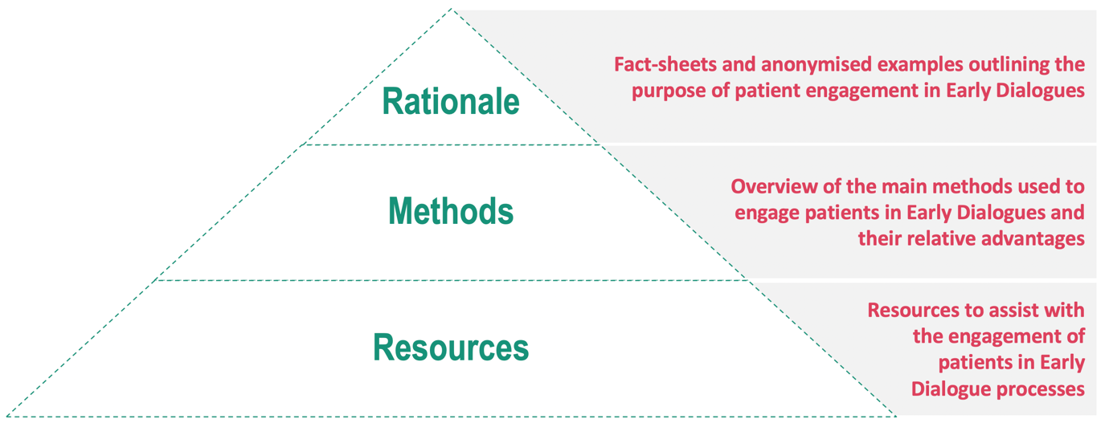

Format of these tools
To ensure that HTA bodies can adapt and edit these tools, they are provided in editable Microsoft Word format. Each tool or resource can be used as a stand-alone tool, allowing each HTA body to select the tools that most closely match its Early Dialogue process. Most resources are one or two pages long to provide simple, focused guidance and direction. HTA bodies are free to add to or amend these resources as their needs evolve.

How these tools were developed
A series of workshops were held with HTA bodies involved in Early Dialogue processes. These workshops were facilitated by the HTAi Patient and Citizen Involvement in HTA Interest Group (PCIG). Working collaboratively, the HTA bodies identified critical areas where tools would help in the patient engagement process for Early Dialogues. PARADIGM and PCIG would like to thank the following HTA bodies and network for their contributions:

AEMPS: Agencia Española de Medicamentos y Productos Sanitarios (Spain)*
AIFA: Italian Medicines Agency (Italy)*
IACS: Aragon Health Sciences Institute (Spain)
CADTH: Canadian Agency for Drugs and Technologies in Health (Canada)
G-BA: Gemeinsamer Bundesausschuss (Germany)*
HAS: Haute Autorité de Santé (France)*
RER: Regione Emilia-Romagna (Italy)*
NICE: National Institute for Health and Care Excellence (England)
NIPN: National Institute of Pharmacy and Nutrition (Hungary)*
NOMA: Norwegian Medicines Agency (Norway)*
TLV: Tandvårds-Läkemedelförmånsverket (Sweden)*
* as representatives from the European Network for Health Technology Assessment (EUnetHTA) Early Dialogue Working Party (EDWP)

Advice from these HTA bodies led to the content, size and format of the tools within this resource. The authors would also like to thank Karen Facey for volunteering her time to co-facilitate the final HTA workshop.

[Back to contents page]

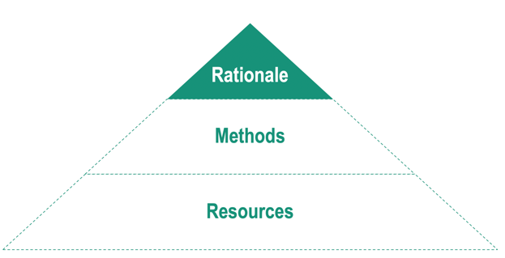

SECTION 1: The Rationale for engaging patients in Early Dialogues
This section contains the following resources:

- Fact sheet: What are Early Dialogues?
- Fact sheet: Why take part in an Early Dialogue? (for patients)
- Fact sheet: Why engage patients in Early Dialogues? (for HTA bodies)
- Vignettes: Anonymised examples of the value of patient engagement in Early Dialogues
- Template: A template with instructions for capturing further vignettes
(note only for use by HTA bodies to ensure confidentiality is preserved)

About the tool:

Fact Sheet: What are Early Dialogues?

Who is it for? | HTA bodies to use with patients and other stakeholders who are being invited to take part in an Early Dialogue process
What is its purpose? | To outline the purpose of Early Dialogues so that patients understand the concept of Early Dialogues when making a decision about whether to be involved

Fact Sheet: What are Early Dialogues?
Early Dialogues, sometimes called Scientific Advice, is a process where a developer of a medicine can confidentially share the plans for their research with medicine regulators and/or Health Technology Assessment (HTA) bodies to gain feedback and advice.

Most commonly, Early Dialogues take place to provide advice on the design of clinical trials. HTA bodies and regulators can comment on the proposed clinical trials design and recommend additions or changes so that the evidence generated in the clinical trial more closely meets the requirements when it is assessed in the future.

Triggered by the medicine developer
Early Dialogues are not mandatory. The medicine developer chooses if and when to apply for an Early Dialogue process.

Advice, not a formal decision
The HTA bodies and/or regulators involved in an Early Dialogue process provide advice but do not make any formal assessment or decisions on the medicine at this time. It is up to the medicine developer to decide if they implement the recommendations in their clinical trials. Implementing the advice does not guarantee that a future assessment of the medicine will be successful.

Confidential process
Plans for clinical research are highly confidential as they contain commercially sensitive information about a potential medicine. All stakeholders involved in Early Dialogues are required to sign strict confidentiality agreements to ensure no information is shared by anyone beyond the Early Dialogue process.

Timing of an Early Dialogue process
Usually, medicines developers seek advice before the design of clinical trials are fixed. This allows them to consider the recommendations given as they refine the design of their clinical trials.

Areas usually discussed within an Early Dialogue
The medicine developer usually poses a list of questions they would like advice on, and these normally cover specific aspects of their clinical trial designs such as:

- The overall design of a clinical trial
- The profile of patients that will be recruited into the trial and those that will be excluded
- The measurements that will be recorded in the clinical trial (clinical trial endpoints)
- The existing medicine or clinical process that the new medicine will be compared with (the comparator)
- The quality of life measures that will be used to assess how patients’ health and wellbeing are impacted during the clinical trial
- Any analysis being planned to show the economic impact of the potential medicine on the healthcare system
- Details of how the data from a clinical trial will be statistically analysed

Further reading
Below are links to additional third-party resources and explanations of Early Dialogues. Note that the documents are mainly written for the medicines developers and so may contain terminology that will be unfamiliar to other stakeholder groups such as patients.

EUnetHTA Early Dialogues:
Provides an overview of the Early Dialogue programs provided by EUnetHTA and the three main approaches used to gain input from external experts such as patients and doctors.

EMA Best Practice Guidance for Parallel Scientific Advice with HTA bodies:
A guidance document for medicines developers that explains the process of seeking advice in parallel from the medicine regulator (EMA) and HTA bodies.
NICE Scientific Advice Program:
Provides an overview and an animated video to explain the NICE Scientific Advice process and the value of including patients in the process.

CADTH Scientific Advice Program:
Provides an overview of the Early Dialogues program available in Canada and describes the patient involvement process used during these Early Dialogues.

[Back to contents page]

[Back to start of Section 1: The Rationale for engaging patients in Early Dialogues]

About the tool:

Fact Sheet: Why take part in an Early Dialogue? (for patients)

Who is it for? | HTA bodies to share with patients who are being invited to take part in an Early Dialogue process
What is its purpose? | To outline the purpose and value of patient engagement during an Early Dialogue process and answer some common questions

Fact Sheet: Why take part in an Early Dialogue? (for patients)

The value of patient involvement in Early Dialogues
Involving patients in Early Dialogues improves the quality of the advice given to medicines developers, leading to better evidence of a medicine’s impact on patients’ health and quality of life.

Overview
Early Dialogue, sometimes called Scientific Advice, is a process where a developer of a medicine can confidentially share their plans for research with medicine regulators and Health Technology Assessment (HTA) bodies to gain feedback and advice.

During an Early Dialogue you can offer valuable views and advice on:
- Any issue or topic area that comes up that you have a view on, some examples include, but are not limited to:
  - What it is like to live with this condition
  - What patients expect from a new treatment for this condition
  - How suitable the proposed clinical trial is for patients like you

This helps companies who are planning to collect evidence for a medicine to understand the potential impact it could have on people like you, and your family and caregivers. Your contribution to this process ensures that your view is being heard at a time when the people developing the medicine can change the design of a clinical trial to reflect what they learn from you.

In many cases patient feedback has led to clinical trials that are better suited to collecting evidence about what matters to patients with the condition.

Will I need scientific knowledge to take part?
No. While some knowledge of the medicine development process can be helpful, your role is to be a patient expert*. Your expertise comes from your experience of living with the condition. We call your expertise a patient perspective. You can give a patient perspective on the practicalities of managing the condition and undergoing treatment. You can also offer helpful insights into what any proposed clinical trial might mean for patients, their caregivers and families.

How exactly will I be involved?
The HTA body that has contacted you will explain how they would like you to take part and how it will work. It might be in an interview or meeting or both:

- Interview: You may be interviewed by a member of the HTA body about your experience and views. The interviews normally last about one hour.
- Meeting: You may be invited to a meeting with the HTA body and the medicine developer where you will have an opportunity to join in the discussions. These meetings often last around three hours.
What kind of topics will I be able to comment on during the process?
The medicine developer usually has a list of questions they would like advice on, and these normally cover specific aspects of their clinical trial designs such as:

- The general design of a clinical trial
- Which patients will be included in (or eligible for) the trial and which will be excluded?
- What will be measured in the clinical trial (clinical trial endpoints) and how it will be measured
- The existing medicine or clinical process that the new medicine will be compared to (the comparator)
- How and when the quality of life of patients in the trial will be measured to assess how patients’ health and wellbeing are impacted during the clinical trial
- The approach the medicines developer is planning to show the economic impact of the potential medicine on the healthcare system

Each Early Dialogue is unique, and you are free to comment on any aspect that you feel is of relevance. As a patient living with this condition, you may have views on many of these aspects as well as views on the relevance of the suggested approach for collecting evidence on your condition. For example, do you see any practical concerns for people with the condition taking part in the clinical trial, taking into account the length of the trial? You may have some advice on how the medicine developer can better collect evidence on the quality of life of patients in the clinical trial.

What kind of information will be provided to help me prepare?
The company developing the medicine normally provides the HTA body with a document called a Briefing Book which outlines the details of the medicine being developed as well as a description of how the company plans to collect evidence in clinical trials. If this Briefing Book can be shared with patients, then you will be able to read about it and think about what it might mean for patients who may take part in the trials or use the medicine one day. In some cases, the Briefing Book is not available or cannot be shared, in which case you may be given an overview of the key points on a call or provided with a written summary in plain language.

If you are being interviewed as part of this Early Dialogue process, you should receive the interview questions in advance to help you prepare.

Why do I have to sign so many forms?
These forms are to protect your rights, the rights of others involved in the Early Dialogue and ensure the process is suitable and has credibility.
Confidentiality agreement: Plans for clinical research are highly confidential as they contain commercially sensitive information about a potential medicine. All stakeholders involved in Early Dialogues must sign strict confidentiality agreements.

Declaration of interests: It is also common to have to declare any interests that you or your family may have in relation to the disease and the companies developing medicines. The HTA body will provide you with information on what interest should be declared. Previous engagement with a medicine developer may exclude you from a particular Early Dialogue process.

Contract: Patient experts are usually compensated for the time and expenses in taking part. Like all other stakeholders involved, you will need to sign a contract that makes clear what expertise you are providing and how this will be compensated for.

Informed consent: Patient experts need to know if there are any risks in taking part and their rights, including not taking part or stopping taking part.

Further reading
Below are links to additional third-party resources and explanations of patient involvement in Early Dialogues:

EUPATI: An introduction to clinical research:
For those new to clinical trials and clinical research, this video gives a brief and clear explanation of the basics of clinical trial purposes and designs

EUPATI Guidance for patient involvement in regulatory processes:
An overview of patient involvement with regulators and HTAs that includes Scientific Advice

Patient Involvement in the CADTH Scientific Advice Program:
Provides an overview of the patient involvement process in the Pan-Canadian early dialogue program.

EUnetHTA Early Dialogues:
Provides an overview of the Early Dialogue programs provided by EUnetHTA and the three main approaches used to gain input from external experts such as patients and doctors. EUnetHTA includes the participation of many national HTA bodies in Early Dialogues.

[Back to contents page]

[Back to start of Section 1: The Rationale for engaging patients in Early Dialogues]

About the tool:

Fact Sheet: Why engage patients in Early Dialogues? (for HTA bodies)

Who is it for? | For HTA bodies with Early Dialogue processes which do not currently involve patients
What is its purpose? | To outline the rationale and answer common misconceptions about patient engagement in Early Dialogue processes

Fact Sheet: Why engage patients in Early Dialogues? (for HTA bodies)

The value of patient involvement in Early Dialogues
Involving patients in Early Dialogues improves the quality of the advice and recommendations given, leading to improved evidence on a medicine’s impact on patients’ health and quality of life.

Patient engagement improves the dialogue and advice given
Early Dialogues are a timely opportunity to guide medicines developers on their clinical programs and evidence generation plans. Patients living with the disease have unique insights into the challenges the disease causes and the practicalities of being involved in a clinical trial for the disease. They can comment on many aspects of clinical trial design, the suitability of endpoints to capture the experienced disease and treatment burden, the appropriateness of the comparator and the potential impact of patient inclusion and exclusion criteria.
The timing of Early Dialogues is ideal to positively impact evidence plans
Patient engagement means that the companies collecting evidence for their product can gain feedback on its potential impact on those who might take it, and their families and caregivers, and find out what matters most to them.

Early Dialogues happen early enough to impact clinical programs, meaning that patient insights provided at this point in time can prompt changes to study designs so that the evidence generated will more closely reflect the needs and realities of patients with the condition.

Ensures directly affected stakeholders are included
Some patients with the condition will be exposed to the clinical trials of the medicine. They will have opinions and perspectives on the practicalities of proposed clinical programs as well as particular procedures outlined in the proposed study designs. Patients will also have views on the outcomes that most matter to them, such as how it might impact the most bothersome symptoms, or how it could impact the overall quality of life. Any potential negative impacts of a potential medicine can also be explored from the patient perspective. It is important that patients are included in Early Dialogues in order to capture these views.

Dealing with confidentiality and conflict of interests
Patient experts involved in Early Dialogue processes are under the same contractual, non-disclosure and declaration of interest rules as any other stakeholder. During the selection process, they are made aware of the rules and operating procedures inherent in the Early Dialogue process and sign the same forms and legal documents as other stakeholders.

The HTA body can use existing processes and forms or adapt the template forms contained in the PARADIGM Patient Engagement in Early Dialogues: Tools and resources for HTA bodies.

Patient engagement in complex and scientific dialogues
It is important to clearly define the role of all stakeholders involved in Early Dialogues. As patient experts, the patients can comment on many aspects of the evidence generation plans and the feasibility, from the patient perspective, of particular study protocols. Other stakeholders such as clinicians and economists perform different roles during the Early Dialogue and can address detailed scientific and economic questions.

So, although it is sometimes possible to find patient experts that are also scientifically knowledgeable, it is not necessary for a successful Early Dialogue. What is important is that patients taking part understand their role and have an opportunity to express their perspectives so that the medicine developer can reflect on their insights and improve the relevance of research.

Resources to help get started
As part of the IMI project PARADIGM, a set of templates and resources have been developed to help start or evolve patient engagement in Early Dialogue efforts. These include:

Fact Sheet: What are Early Dialogues
Fact Sheet: Why take part in an Early Dialogue? (for patients)
Fact Sheet: Overview of main processes and methods
Guidance: Recruiting patient experts for an Early Dialogue process
Checklist: Recruiting and contracting patient experts into an Early Dialogue process
Sample Documents: Recruiting and contracting patient experts into an Early Dialogue process
Guidance: Preparing pre-read material for preparing patients to input into an Early Dialogue (Briefing Book)
Template: Summary of Early Dialogue Briefing Book for patients
Illustrative sample: Interview discussion guide for an Early Dialogue
Checklist: Preparing for a face-to-face meeting
[Back to contents page]

[Back to start of Section 1: The Rationale for engaging patients in Early Dialogues]

About the tool:

Vignettes: Examples of patient engagement in Early Dialogues

Template: A blank template for use to collect further examples

Who is it for? | For HTA bodies and other stakeholders involved in Early Dialogues (including industry and patients)
What is its purpose? | To provide anonymised examples that can be shared without breaking any confidentiality agreements
What is the template for? | To provide a simple and quick way of capturing the value of patient input into Early Dialogues in a way that preserves confidentiality (for use by HTA bodies only)

Vignette 1: Patient input on trial design and endpoints

The table below captures the essence of patient input into an Early Dialogue. This vignette has been anonymised to remove any reference to the product and disease area.

DISEASE AND TREATMENT TYPE | - Gene therapy for a chronic rare disease
ISSUES IDENTIFIED | - Single arm trial will reduce robustness of evidence to assess value  - Quality of Life driven outcomes with endpoint measured by a PRO tool  - Historical data from patients will need to be collected in the trial protocol
PATIENT INPUT ON THE ISSUES IDENTIFIED | - Endpoints: Questioned the suitability of the PRO tool proposed, in particular identified missing domains in the proposed PRO tool and gave advice on the frequency and timing of the PRO measurement  - Data collection: Offered advice on which historical timepoint data should be collected on the patients  - Study design: Highlighted that the single arm trial, while not ideal from a robust evidence perspective, ensured that all patients in the trial received active treatment
ADDITIONAL IMPACT/INFLUENCE OF PATIENT INPUT | - Highlighted efficacy and tolerance issues with current treatments

Vignette 2: Patient input on trial design and endpoints

The table below captures the essence of patient input into an Early Dialogue. This vignette has been anonymised to remove any reference to the product and disease area.

DISEASE AND TREATMENT TYPE | - Degenerative neurological disease
ISSUES IDENTIFIED | - Appropriateness of endpoints  - Primary and secondary endpoints (e.g. 6-minute walk test)  - QoL outcome measures  - Because the disease may be very heterogeneous with different outcomes at different stages, questions arose about the relevance of the proposed endpoints
PATIENT INPUT ON THE ISSUES IDENTIFIED | - Endpoints: Patient input questioned the relevance of the endpoints under consideration  - Suggestion was made to focus on endpoints that capture ‘activities of daily living’ and level of independence possible  - The ability to maintain social interactions also should be captured if possible
ADDITIONAL IMPACT/INFLUENCE OF PATIENT INPUT | - Not applicable in this case

Template: Capturing patient input into Early Dialogues

The table below and instructions are for use by HTA agencies to capture the elements that show the value of patient input into an Early Dialogue process. It is strongly recommended that only HTA agencies use this template to ensure that complete control over confidentiality is maintained.

DISEASE AND TREATMENT TYPE | - Describe the disease area in very general terms – for example ‘A chronic immunological disease’ rather than ‘Rheumatoid Arthritis’
ISSUES IDENTIFIED | - These are the main issues that the HTA body or bodies identified when reviewing the Briefing Book
PATIENT INPUT ON THE ISSUES IDENTIFIED | - Particular input from the patient(s) involved in the Early Dialogue on the issues identified by the HTA body or bodies. Consider the following areas that patients may have given input on:  - Endpoints: …  - Study design: …  - QoL/PRO considerations: …
ADDITIONAL IMPACT/INFLUENCE OF PATIENT INPUT | - In some cases, the patients may identify new issues that were not identified by the HTA body or bodies reviewing the Briefing Book. These can be captured here …

[Back to contents page]

[Back to start of Section 1: The Rationale for engaging patients in Early Dialogues]

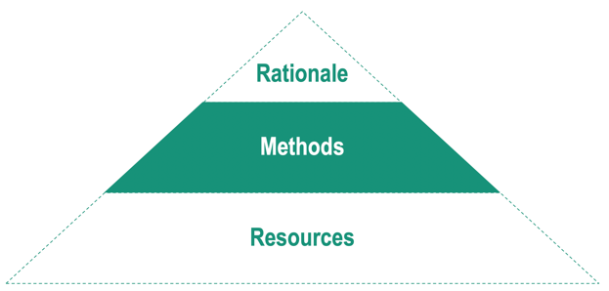

SECTION 2: Guidance on the methods of patient engagement in Early Dialogues
This section contains the following resources:

- Fact sheet: Overview of main processes and methods
- Guidance: Considerations for interviews with patients in an Early Dialogue process
- Guidance: Considerations for meetings with patients in an Early Dialogue process
- Illustrative process flows: For interviews and multi-stakeholder meeting approaches

About the tool:

Fact Sheet: Overview of main processes and methods
Who is it for? | For HTA bodies considering which processes to use to gain patient input
What is its purpose? | To provide a high-level outline of the relative pros and cons of each of the main methods

Fact Sheet: Overview of main processes and methods
A variety of methods are used by different HTA bodies to conduct Early Dialogues. These processes can change over time and are also dependent on the particular form of Early Dialogue being sought by the medicine developer. For example, if this is parallel advice with a regulatory body such as the EMA, then the EMA process for Early Dialogues will apply.

Although there are numerous processes, the two main interaction models for patient engagement in Early Dialogues are:

INTERVIEWS | MULTI-STAKEHOLDER MEETINGS
Where patients are interviewed using a structured questionnaire that focuses on gaining insights to the questions relevant for a particular Early Dialogue | Where patients are invited to a multi-stakeholder meeting including the medicine developer and join in the discussion
Some processes have a mix of these methods, and some include meetings only with the HTA body representatives.

Other methods to gain patient input
Outside of these formal Early Dialogue processes, HTA bodies have access to additional sources of information that they can probe to understand patient perspectives. These include:

- Previous patient input into HTAs: When patients have been involved in the assessment of medicines for an HTA, they will have provided insights on:
  - The burden of disease and how it affects daily activities
  - The patient experience of current treatment approaches
  - Patient expectations around the need for new therapeutic options
- Published literature: There is an increasing wealth of published papers on patient experience and preferences in many disease areas. These can be synthesised to provide background input to the Early Dialogue process and also identify particular questions to ask patients taking part in the process.

Guidance and tools on conducting interviews can be found here:

Guidance: Interview methods
Illustrative sample: Interview discussion guide for an Early Dialogue
Guidance: Ethical considerations for interviews with patients for an Early Dialogue process
Guidance and tools on conducting meetings and teleconferences can be found here:

Guidance: Patient considerations for a face-to-face meeting
Checklist: Preparing for a face-to-face meeting
Guidance: Patient considerations for teleconferences and virtual meetings
Checklist: Preparing for a teleconference or online meeting

Further reading
Below are links to additional third-party resources and explanations of Early Dialogues. Note that the documents are mainly written for the medicines developers and so may contain terminology that will be unfamiliar to other stakeholder groups such as patients.

NICE process and timeline for its Early Scientific Advice Program:
An overview of patient involvement with regulators and HTAs that includes Scientific Advice

Patient Involvement in the CADTH Scientific Advice Program:
Provides an overview of the patient involvement process in the Pan-Canadian early dialogue program.

EUnetHTA Early Dialogues:
Provides an overview of the Early Dialogue programs provided by EUnetHTA and the three main approaches used to gain input from external experts such as patients and doctors.

EMA Best Practice Guidance for Parallel Scientific Advice with HTA bodies:
A guidance document for medicines developers that explains the process of seeking advice in parallel from the medicine regulator (EMA) and Health Technology Assessment bodies.

[Back to contents page]

[Back to start of Section 2: Guidance on the methods of patient engagement in Early Dialogues]

About the tool:

Guidance: Considerations for interviews with patients in an Early Dialogue process

Who is it for? | For HTA bodies considering using interviews to gain patient input into an Early Dialogue
What is its purpose? | To provide the reasons why interviews can be successfully used for Early Dialogues, but also to flag some of the downsides of interviews that need to be mitigated against

Guidance: Considerations for interviews with patients in an Early Dialogue process
Interviews are a common method used to gain patient perspectives on specific issues identified when the HTA body or bodies reviewed the Briefing Book. Interviews have many advantages but do not allow for interactive dialogue with other stakeholders such as the company developing the medicine. This document sets out the advantages, but also some of the disadvantages of interviews.

Reasons to conduct interviews for Early Dialogues

Interviews are scalable, meaning a variety of patients can be interviewed
Once an interview structure and questions have been developed, the interviews can be conducted multiple times with a variety of relevant patients. This allows for a more diverse range of inputs into the Early Dialogue process.

Interviews can be conducted in multiple local languages
Often Early Dialogues are conducted across multiple HTA bodies. Interview methods allow the questions to be translated into the most appropriate local language to ensure that there is no barrier to gaining input from patients in each country.

Interviews can also be conducted with groups of patients
Sometimes the dialogue between patients with the same condition can reveal new issues and topics of interest as participants prompt each other’s thinking. It is possible to conduct interviews one-to-one, but also to conduct the interview with a group of patients on a teleconference call. This allows patients to discuss their responses with each other and refine their input.

Interviews can be written up and reviewed by the participants
To ensure that the HTA body or HTA bodies have captured the essential feedback from the interviewees, interview notes can be shared back with participants. Any misunderstandings in the response of the interviewees can be corrected before integrating in the final report to the medicine’s developer.

Interviews provide a focused opportunity to hear from patients
Because the interviews are focused on gaining patient input, there are no other stakeholders to consider in the interview. This means that the time spent interviewing the patients is not interrupted with the views of other stakeholders.

Interviews can be adapted to focus on issues that are specific to an Early Dialogue
Upon reviewing the briefing book supplied by the medicine developer, the HTA body or HTA bodies will have identified particular themes and issues that need patient input. Time in the interview can be devoted to answering these specific questions.

Downsides of interviews to mitigate against

The time commitment from HTA staff may be higher
If multiple interviews are to be conducted then recruiting, preparing for, conducting, checking transcriptions, and writing up the interview report can be time-consuming. Additionally, if group interviews are to be held, scheduling can take longer. Standard processes and templates that can be shared across multiple agencies can speed up the processes.

Ensuring a standard approach can be more difficult
When conducting multiple interviews in different languages, it can be difficult to ensure that every interview is following the same methodology and structure. Agreeing a structured questionnaire at the beginning of this process can alleviate this risk.

Translation costs can be high
There are several translation steps needed when conducting interviews in multiple languages:

- Translating the agreed interview questions into multiple languages
- Translating each interview output back into the language of the Early Dialogue report
- Translating any corrections or feedback after interview notes are shared with interviewees
- Translating any final report or feedback of the Early Dialogue process back to the interviewees who took part

Using templates that can be translated once and then adapted locally can help. Also, agreeing a process on feedback to interviewees that reduces the number of translation steps can reduce some of these costs.

Dialogue between stakeholders is not possible
Unlike a multi-stakeholder meeting where the patients are able to respond to emerging issues and dialogue, the interview captures only the areas that patients are asked. It is possible to mitigate this risk by ensuring that open and general questions are asked during the interview.

Expertise of interviewer
Interviews depend on the skills of interviewers, especially to encourage relevant responses and reflection and to ensure group interviews benefit from dialogue between participants while remaining sufficiently focused on the questions to be addressed. Online and face-to-face courses are recommended to help interviewers refine their skills.

Resources to help with interviews
In this PARADIGM resource, there are several tools that can help overcome some of the challenges with interviews, including:

Guidance: Interview methods
Illustrative sample: Interview discussion guide for an Early Dialogue
Guidance: Ethical considerations for interviews with patients for an Early Dialogue process

[Back to contents page]

[Back to start of Section 2: Guidance on the methods of patient engagement in Early Dialogues]

About the tool:

Guidance: Considerations for meetings with patients in an Early Dialogue process

Who is it for? | For HTA bodies considering using meetings (either face to face or online) to gain patient input into an Early Dialogue
What is its purpose? | To provide the reasons why meetings can be successfully used for Early Dialogues, but also to flag some of the downsides of meetings that need to be mitigated against

Guidance: Considerations for meetings with patients in an Early Dialogue process
Many HTA bodies use a variety of meetings to gain input from patients in an Early Dialogue process. These meetings can vary in terms of the stakeholders attending, but often include all the relevant stakeholders including the medicine developer, the HTA body or bodies, the clinical experts and the patient experts. This document sets out the advantages, but also some of the disadvantages of meetings. The success of these meetings is very dependent on the preparation, including ensuring all attendees, including patient attendees are well briefed on what to expect at the meeting.

Reasons to conduct meetings for Early Dialogues

Meetings are dynamic and allow for the emergence of new issues
In a meeting there are often many points of view from different stakeholder groups. With strong chairing skills, this can generate an evolution of the issues under consideration as each stakeholder brings their perspective to the table.

Meetings allow for patients to respond to the views of other stakeholders
As each stakeholder voices their perspective, it is possible for the patient(s) in the meeting to respond to these perspectives in a way that is not possible in a one-to-one interview approach.

Unlike interviews, the meeting is run only once
In many circumstances all participants attend the same meeting, reducing duplication in terms of scheduling, conducting and any reporting of the patient input.

There is flexibility in how meetings are held
Although traditionally Early Dialogue meetings have been face-to-face meetings, there are now opportunities to conduct these meetings virtually using a technology platform. This can further reduce the administration and costs of running an Early Dialogue meeting, though care needs to be taken to ensure that all attendees are comfortable with the technology and confident to voice their opinion in the virtual room and accessibility issues are addressed.

The Chair of the meeting can ensure patient issues are heard
It can be daunting for patient experts to attend an Early Dialogue meeting, which is why the chairs of these meetings are trained to ensure that the patient perspectives are heard. There are often opportunities for the attending patient experts to meet with the Chair before the meeting so that the Chair understands the key issues, perspectives and concerns that the patient experts have, and can bring them into the discussion at the appropriate moments.

Downsides of meetings to mitigate against

Limited places for patient experts
With interviews, it is possible to interview many patients, but an Early Dialogue meeting has only limited capacity for external experts, including patient experts, and so it is not possible to have the same diversity of views. Careful selection of the attending patient experts will ensure that an active dialogue can be had that identifies the key patient perspective points.

Can be a daunting experience for some
It is important that the patient experts attending are well prepared and confident to voice their perspective. A pre-teleconference call with the patient experts can be used to ensure that the key issues the patient experts will raise are understood and flagged to the team preparing the Early Dialogue as well as the Chair of the meeting. Guidance and documents that help the patient experts understand their role and the process will also help patients feel more comfortable.

Limited time can be devoted exclusively to patient input
Early Dialogue meetings can involve up to 20 people, with only a few of these being patient experts. Having a strong Chair of the meeting who has been pre-briefed on the issues that patient experts would like to voice will help ensure that the patient perspective is addressed in the meeting and that the patients are heard. Guiding patients on the meeting etiquette such as raising their hand if they have a point to add will also ensure active participation.

Meetings conducted in a single language
It is usually not possible to conduct a live Early Dialogue meeting in multiple languages. That means that the participating patient experts must be comfortable in both understanding the dialogue as it evolves and voicing their perspectives in the language of the meeting. This is not normally a problem for Early Dialogues happening with just one HTA body, but for joint dialogues with multiple HTA bodies from different countries, this can be an issue. To mitigate against this, it is important to select patient experts to attend the meeting that are confident in the language of the meeting.

Expertise of Chair
Effective patient engagement in Early Dialogue meetings depends on Chairs having skills and knowledge about patient engagement and patient expertise. A Chair that lacks knowledge or training about the value of patient experts’ contributions or contests the rationale for it, is likely to be a barrier to effective engagement.

Resources to help with meetings
In this PARADIGM resource, there are several tools that can help overcome some of the challenges with meetings, including:

Guidance: Patient considerations for a face-to-face meeting
Checklist: Preparing for a face-to-face meeting
Guidance: Patient considerations for teleconferences and virtual meetings
Checklist: Preparing for a teleconference or online meeting

[Back to contents page]

[Back to start of Section 2: Guidance on the methods of patient engagement in Early Dialogues]

About the tool:

Illustrative process flows: For interviews and multi-stakeholder meeting approaches
Who is it for? | For HTA bodies considering either interviews or multi-stakeholder meetings for an Early Dialogue
What is its purpose? | To provide an illustrative and high-level process and timeline so that the two approaches can be compared

Illustrative process flows: For interviews and multi-stakeholder meeting approaches
There are a variety of processes used by HTA bodies, often with a mix of methods. The example process flows and timelines below are adapted from two Early Dialogue processes, the NICE (England) approach using a face-to-face multi-stakeholder meeting and a EUnetHTA approach that is focused purely on interviews with external experts. It should be noted that EUnetHTA adopts other approaches that includes patient participation in an Early Dialogue multi-stakeholder meeting.

Illustrative example process for using an Early Dialogue meeting to gain patient expert input into an Early Dialogue
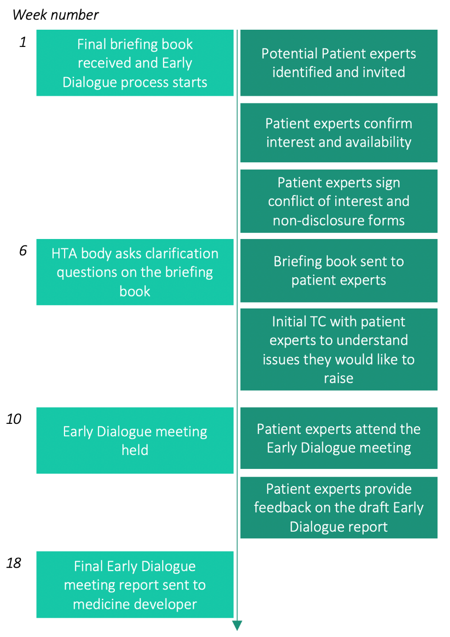

Illustrative example process for interviewing patients experts to gain input into an Early Dialogue

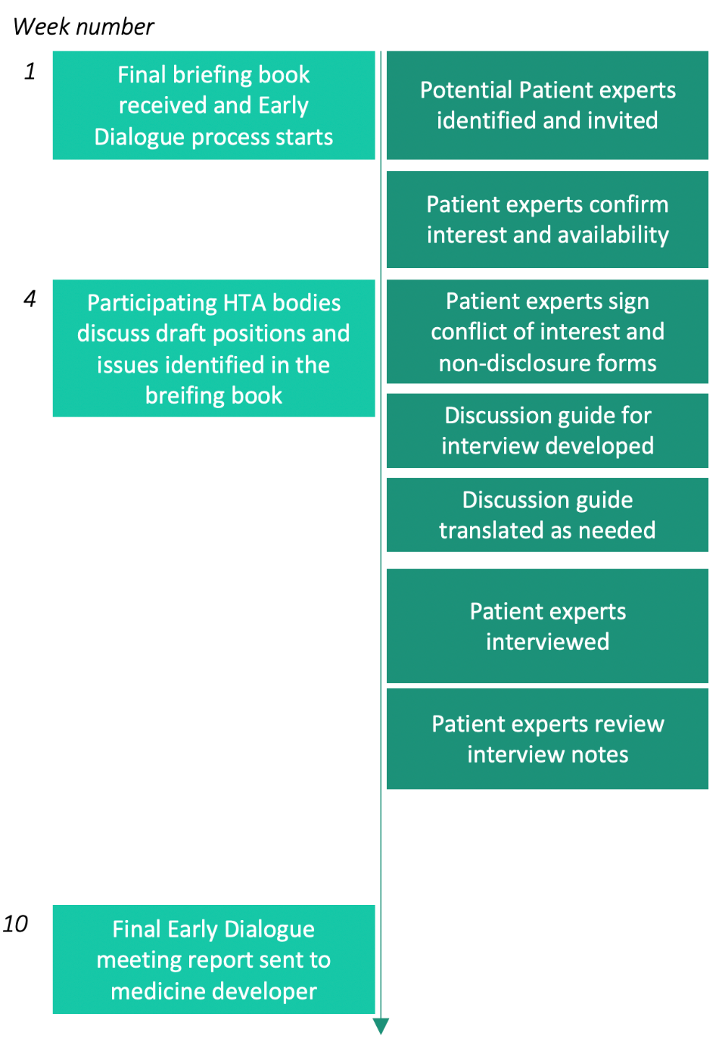

Further reading
Below are links to additional third-party resources and explanations of Early Dialogues. Note that the documents are mainly written for the medicines developers and so may contain terminology that will be unfamiliar to other stakeholder groups such as patients.

NICE process and timeline for its Early Scientific Advice Program:
An overview of patient involvement with regulators and HTAs that includes Scientific Advice

Patient Involvement in the CADTH Scientific Advice Program:
https://cadth.ca/scientific-advice/patient-involvement
Provides an overview of the patient involvement process in the Pan-Canadian early dialogue program.

EUnetHTA Early Dialogues:
Provides an overview of the Early Dialogue programs provided by EUnetHTA and the three main approaches used to gain input from external experts such as patients and doctors.

EMA Best Practice Guidance for Parallel Scientific Advice with HTA bodies:
A guidance document for medicines developers that explains the process of seeking advice in parallel from the medicine regulator (EMA) and Health Technology Assessment bodies.

[Back to contents page]

[Back to start of Section 2: Guidance on the methods of patient engagement in Early Dialogues]

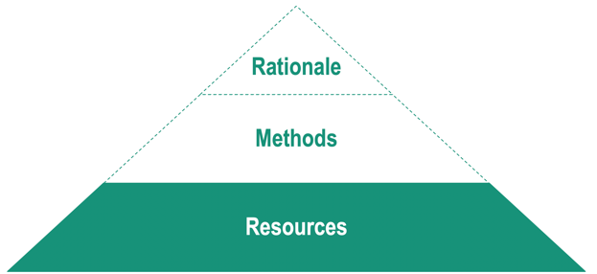

SECTION 3: Resources to support HTA bodies in engaging patients for Early Dialogues
This section contains the following resources:

Recruitment resources
- Guidance: Recruiting patient experts to an Early Dialogue process
- Process: Recruiting and contracting patient experts into an Early Dialogue process
- Checklist: Recruiting and contracting patient experts into an Early Dialogue process
- Sample Documents: Recruiting and contracting patient experts into an Early Dialogue process

Preparing pre-read materials
- Guidance: Preparing pre-read material for preparing patients to input into an Early Dialogue (Briefing Book)
- Template: Summary of Early Dialogue Briefing Book for patients

Interviewing patients for an Early Dialogue process
- Guidance: Interview methods
- Illustrative sample: Interview discussion guide for an Early Dialogue
- Guidance: Ethical considerations for interviews with patients for an Early Dialogue process

Preparing for face-to-face meetings, teleconferences and virtual meetings
- Guidance: Patient considerations for a face-to-face meeting
- Checklist: Preparing for a face-to-face meeting
- Guidance: Patient considerations for teleconferences and virtual meetings
- Checklist: Preparing for a teleconference or online meeting
- Template: Feedback form for patient experts attending a face-to-face meeting
- Template: Feedback form for patient experts attending an Early Dialogue teleconference meeting
- Template: Feedback form for patient experts attending an Early Dialogue virtual meeting
- Template: Thank you and feedback letter

About the tool:

Guidance: Recruiting patient experts for an Early Dialogue process
Who is it for? | For HTA bodies considering either interviews or multi-stakeholder meetings for an Early Dialogue
What is its purpose? | To provide an illustrative and high-level process and timeline so that the two approaches can be compared

Guidance: Recruiting patient experts for an Early Dialogue process
This tool has been created from the outputs of the PARADIGM workshops with HTA bodies, internal documents which have been shared from these bodies, and the published G-I-N Public Toolkit from The Guidelines International Network which contains comprehensive and useful guidance on recruiting patients into processes for clinical guidelines. The full G-I-N toolkit can be accessed here.

Adaptation has been made to tailor the guidance for HTA bodies recruiting to Early Dialogue processes.

The main steps in patient recruitment

Be clear on the role you are asking patient experts to take
It is useful to clearly define the role patients will play in the meeting from the outset, and the basic criteria required for a patient to fulfil the patient expert role. The criteria can be more clearly defined after an initial review of the Briefing Book from the medicine developer to understand the target patient population that the developer is aiming for.
Examples of criteria include (but are not limited to):

- Patient experience of the condition most applicable to the specific Early Dialogue in question
  - In some cases, it is not possible to identify a patient with the condition due to the nature of the disease or because it is a condition which affects children. In these cases, a parent or caregiver may be able to provide the insights needed
  - Depending on the nature of the Early Dialogue, a patient at a particular stage of disease, or with a particular treatment history may be needed to answer the specific questions in the Early Dialogue
- A patient expert willing to devote the required time to prepare for the Early Dialogue and attend the various meetings, calls and interviews
- Understands the need for confidentiality and has a willingness to declare any interests
- Confident speaking about his/her experience with the disease, its treatments and management
- Has sufficient fluency in the language of any meetings, teleconferences or interviews

It is good practice to recruit two or more patient experts to an Early Dialogue if possible, to have a variety of views and perspectives. Additionally, it may reduce the pressure on individual patient experts, especially in terms of their perceived responsibility to their community or if reduced health prevents them from attending.

Recruitment strategies
With short timelines to find patients for Early Dialogues it is often not possible to advertise for these roles and screen applications (open recruitment strategies). Patient nomination is more often used. This relies on reaching out to networks of patient groups, patient organisations or physician groups and asking them to nominate patients to be part of the Early Dialogue.

Some HTA processes start the recruitment process before receiving the final Briefing Book from the medicine developer. For example, the EUnetHTA Early Dialogue Working Party starts to identify patients as soon as it has accepted an Early Dialogue request. The aim is to have the patient(s) identified and paperwork completed by the time the final Briefing Book is received if possible.

HTA bodies also have their own network of patient organisations which have been involved in the Health Technology Assessment of medicines. If an HTA in this particular disease area has been conducted, then it is possible that the patient groups who input into the assessment may be able to nominate a relevant patient expert for the Early Dialogue.

It is also important to have clear policies on any financial compensation you will offer patient experts before any recruitment starts. This can include reasonable travel expenses and compensation for time and expertise. This is likely to be governed by local and national policies.

Screening and onboarding
Once potential patient experts have been identified, it is good practice to host screening calls with them. This is a two-way process that allows the potential patient expert to find out more about the Early Dialogue process and the role of patient experts in that process. It also allows the HTA body to assess the level of knowledge this potential patient expert has and their ability to express themselves and discuss their condition.

It is important at this point to emphasise the confidential nature of Early Dialogues and the need for patient experts to declare conflicts of interests.

It is also essential to have a clear form of words to communicate any decision not to include a particular patient in the process. This is often because another patient has been selected who more closely matches the disease and treatment experience needed for this particular Early Dialogue. Be as specific as possible about the criteria applied so that the patient understands why they have not been selected for this particular Early Dialogue.

Contracting
Once patient experts have been selected and have agreed to participate, it is important that they sign an informed consent and the relevant documents that will allow them to receive the background information on the Early Dialogue. Often this includes:

Confidentiality agreement: All stakeholders involved in Early Dialogues are required to sign strict confidentiality agreements to ensure confidentiality is maintained.

Declaration of Interests: That the patient expert and his/her family may have in relation to the disease and companies developing medicines.

Contract: Patient experts are usually compensated for their time and expenses in taking part. This will require patient experts to sign a contract that makes clear the expertise being provided.

Resources to help with recruitment
In this PARADIGM resource, there are several tools that can help overcome some of the challenges with recruitment, including:

Guidance: Recruiting patient experts to an Early Dialogue process
Process: Recruiting and contracting patient experts into an Early Dialogue process
Checklist: Recruiting and contracting patient experts into an Early Dialogue process
Sample Documents: Recruiting and contracting patient experts into an Early Dialogue process

[Back to contents page]

[Back to start of Section 3: Resources to support HTA bodies in engaging patients for Early Dialogues]

About the tool:

Process: Recruiting and contracting patient experts into an Early Dialogue process

Who is it for? | For HTA bodies preparing an Early Dialogue process that includes attendance by patient experts
What is its purpose? | To provide a high-level overview of the recruitment steps

Process: Recruiting and contracting patient experts into an Early Dialogue process

The simplified timeline below shows the basic steps in a recruitment process, regardless of the methodologies used to later engage the patient experts in the Early Dialogue process.
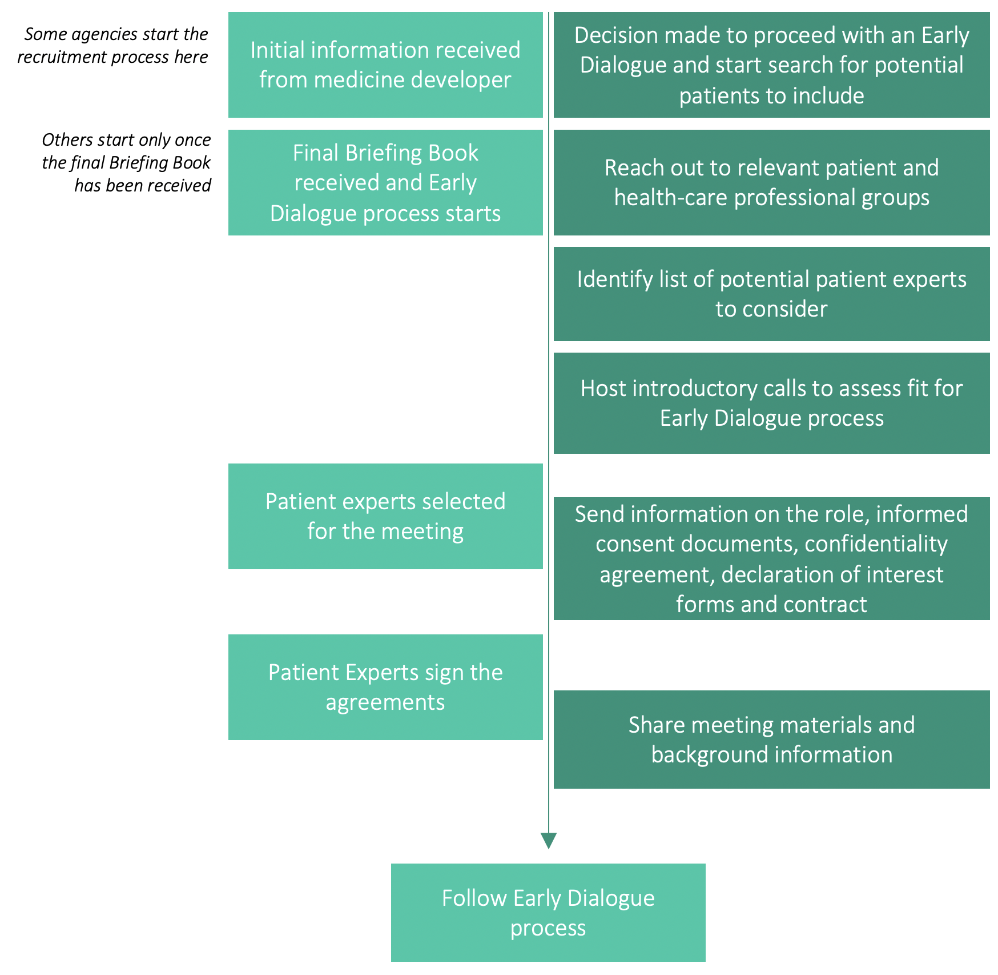

[Back to contents page]

[Back to start of Section 3: Resources to support HTA bodies in engaging patients for Early Dialogues]

About the tool:

Checklist: Recruiting and contracting patient experts into an Early Dialogue process

Who is it for? | For HTA bodies preparing an Early Dialogue process that includes attendance by patient experts
What is its purpose? | To provide a high-level overview of the recruitment steps

Checklist: Recruiting and contracting patient experts into an Early Dialogue process

The following checklist covers the key steps needed to identify and recruit a patient expert into an Early Dialogue process:

Define role of the patient expert
☐ | A clear description of the patient expert role (generic to all conditions)
☐ | A summary of the patient expert participation points in the process  (including whether any are optional)
☐ | A guide to Early Dialogues, written for patients, explaining the role
Analysis of the Briefing Book from the medicine developer
☐ | A clear patient profile described in the Briefing Book, if not seek clarification
☐ | Does the patient expert need to have any other clinical characteristics or disease history (for example, does the patient expert need to be at a particular stage of disease, or have experience of specific treatment of clinical approach)?
Identifying potential patient experts
☐ | Drafted a description of the patient profile needed
☐ | Shared profile with relevant patient group contacts and HCP networks
☐ | Checked to see if an HTA has been performed in this disease area and if so, checked potential contacts that could be reached from that HTA
☐ | Identified list of potential candidates for Early Dialogue process
☐ | Scheduled screening calls to explain the process and assess the fit for this Early Dialogue
☐ | Select patient experts for the process and send formal invite
☐ | Share policies around travel, remuneration and expenses
☐ | Contacted patients who have not been selected to clearly explain why
Contracting the patient experts
☐ | Provided background materials explaining declaration of interest and confidentiality
☐ | Sent patient expert role information, informed consent documents and contact details for support services for patients experiencing difficult emotions
☐ | Sent non-disclosure agreement, declaration of interest form and contract
☐ | Offered a second call to explain any of the terms in the contractual documents
☐ | Received all documents completed and signed
[Back to contents page]

[Back to start of Section 3: Resources to support HTA bodies in engaging patients for Early Dialogues]

About the tool:

Sample Documents: Recruiting and contracting patient experts into an Early Dialogue process

Who is it for? | For HTA bodies preparing an Early Dialogue process that includes attendance by patient experts
What is its purpose? | To provide publicly available sample documents covering:  - Conflict of interest guidelines  - Confidentiality forms  - Contract principles  - Expenses / Honoraria

Sample Documents: For contracting patient experts into an Early Dialogues process

Non-disclosure agreements, legal contracts and declarations of interest forms vary from country to country and are related to local laws and the individual policies of HTA bodies. As such, legal advice is needed to finalise these documents and this resource does not recommend a template approach. Instead, this resource shares some publicly available documents from HTA agencies and other stakeholders that can be looked at and assessed by legal and policy teams.

Confidentiality guidelines and non-disclosure agreements
CADTH, the pan-Canadian HTA body, has published extensive guidelines on conflicts of interest. This covers the general rules about confidentiality as well as the specific documents that CADTH can share with authorised recipients in an Early Dialogue process (known as Scientific Advice):

Confidentiality Guidelines for CADTH Scientific Advice | LINK

CADTH non-disclosure agreement | LINK

EUnetHTA confidentiality agreement | LINK

Declaration of interest policies and forms
EUnetHTA has published a comprehensive guidance and forms on conflicts of interest. The guidance covers examples of major conflicts and outlines how conflicts of interest are evaluated. CADTH has similarly developed a comprehensive Conflict of Interest Guideline which includes template forms for participants to use.

EUnetHTA Procedure Guidance for handling Declaration of Interests | LINK

EUnetHTA declaration of interest form | LINK

CADTH conflict of interest guidelines for contractors | LINK

Contract principles
The patient advocacy group WeCan has published a range of guiding principles for contracting patients. Although this is written specifically for contracts between the pharmaceutical industry and patients, many of the principles will apply to contracts between HTA bodies and patients.

This work has been further expanded by the PARADIGM Consortium to cover consultancy agreements, speaker agreements, collaboration agreements and advisory board agreements in plain language.

WeCan Guiding Principles on Reasonable Agreements between Patient Advocates and Pharmaceutical Companies | LINK
PARADIGM: Patient engagement agreements explained | LINK

Expenses and honoraria policies
The payment of expenses and honoraria for the time patient experts spend on an Early Dialogue is dependent on local policies. It has been generally recognised that as experts, patients provide value to the Early Dialogue process and should, where possible, be offered payment. Below are a few illustrative payment policies:

INVOLVE policy on payments of fees and expenses | LINK

NICE non-staff reimbursement policy | LINK

[Back to contents page]

[Back to start of Section 3: Resources to support HTA bodies in engaging patients for Early Dialogues]

About the tool:

Guidance: Preparing pre-read material for preparing patients to input into an Early Dialogue (Briefing Book)

Who is it for? | For HTA bodies preparing an Early Dialogue process that includes attendance by patient experts
What is its purpose? | To provide guidance on the pre-reading material on the specific content of an Early Dialogue to help patients prepare their input

Guidance: Pre-read materials for preparing patients to input into an Early Dialogue (Briefing Book)

In order that patients can successfully input into an Early Dialogue process, they will need to understand the details of each particular Early Dialogue. This information is provided to HTA bodies in the form of a ‘Briefing Book’, a dossier of information and questions that form the basis of a particular Early Dialogue.

This Briefing Book usually contains:

- Details of the medicine being researched
- An outline of the proposed clinical trial(s) being considered by the medicine developer
- Key questions that the medicine developer would like addressed in the Early Dialogue

Sharing the Briefing Book with patients and other external experts
Processes vary across HTA bodies, but all Early Dialogues start with a review of the Briefing Book by the HTA body to understand the scope and nature of the Early Dialogue. Depending on the process and the wishes of the medicine developer, this Briefing Book may be shared in full with external experts including patient experts. However, it is not always possible to share the Briefing Book due to confidentiality restraints. Furthermore, as a technical dossier, the Briefing Book is not an accessible document, and may be daunting for some patients to receive.

Plain language summaries and verbal explanations
It is recommended to prepare, or have the medicine developer prepare, a plain language summary of the main topics, themes and questions contained in the Briefing Book. This would allow patient experts who are unfamiliar with the technical terminology to take part in Early Dialogues more successfully and with more confidence. Care must be taken to walk the patient expert through the details on a telephone call, so that they understand the key issues and can ask questions.

[Back to contents page]

[Back to start of Section 3: Resources to support HTA bodies in engaging patients for Early Dialogues]

About the tool:

Template: Summary of Early Dialogue Briefing Book for patients

Who is it for? | For HTA bodies preparing an Early Dialogue process that includes attendance by patient experts
What is its purpose? | To provide a template for adaptation on capturing a plain language summary of the details of a specific Early Dialogue

Adapted from the CADTH Patient Drug Information Form: https://www.cadth.ca/sites/default/files/scientific_advice/SA-Patient-Drug-Information-Form.docx

Template: Summary of Early Dialogue Briefing Book for patients

Who is this medicine for? (Indication) | Describe who this medicine is being developed for  (e.g.: adult patients with uncontrolled severe asthma)
How does the medicine work? | Describe in plain language how this medicine works against the disease in question. A very simple diagram may help to give clarity.
What do you hope the medicine will do? | Describe the aims of treatment with this medicine – what will it potentially deliver to patients
Where will this fit in the treatment journey? | Describe when you think patients will receive this  (e.g.: directly after being diagnosed, when certain other treatments no longer work, when a disease has progressed to a certain point … etc.). A very simple diagram may help to give clarity.
How will patients take this medicine? | What is the route of administration and expected dosage and frequency
Who are you planning to include in the clinical trial | What profile of patients are you planning to recruit to the clinical trial?  What profile of patients are you planning to exclude from the clinical trial
What other medicines will you be testing this medicine against? | In the clinical trial design, what is the comparator?
What are you planning to measure during the trial | Primary endpoints  Secondary endpoints  Quality of Life measures
How will you make these measurements | What procedures / tests will patients be expected to have during the clinical trial  How often will they need to have these procedures / tests
How will the trial be conducted? | How many patients?  Duration of the trial?  Locations (hospital / specialist centres / …)  Frequency of study visits?

[Back to contents page]

[Back to start of Section 3: Resources to support HTA bodies in engaging patients for Early Dialogues]

About the tool:

Guidance: Interview methods
Who is it for? | For HTA bodies preparing an Early Dialogue using interviews with patients as the main input
What is its purpose? | To provide high level guidance on the various approaches that can be considered

Guidance: Interview methods

Several Early Dialogue processes use interviews with patients to gain the input needed. This document focuses on the main methods that are used in interviews. A deeper set of guidance can be found in the Further Reading section at the end of this document:

Structured interviews
Highly structured interviews follow a set questionnaire or discussion guide that is followed step by step, in the same order and sequence for every patient interviewed. The advantage of this approach for Early Dialogues is that it can allow multiple interviews to take place across several countries or regions, with the assurance that each interview is following the same process. This also makes it much easier to collate the findings from the interviews for the Early Dialogue report.

It is not recommended to use semi-structured or unstructured interviews for Early Dialogues as this would lead to inconsistencies in the type and quality of information received from each interview.

One-to-one interviews
The most common method for conducting interviews is one-to-one where a person from the Early Dialogue team interviews a single patient, following the discussion guide or questionnaire. One-to-one interviews can work well for capturing quieter or unheard voices and provide a safe environment for people to share confidential information about their condition and its impact on their life.

Telephone interviews
One-to-one interviews are often conducted over the telephone. This has the advantage of avoiding travel and disruption to the patients and is useful for reaching hard-to-reach patients (such as the housebound or geographically remote). Telephone interviews can make the interviewing process much more cost effective for the HTA body to perform. There are however a few challenges with telephone interviews that need to be mitigated against:

- Reduction of clues into how the patient is feeling or reacting to the questions
Because the patient’s body language and facial expressions cannot be seen, it can sometimes be difficult to assess. This is why it is important to monitor the tone of voice of the interviewee to make sure that they sound comfortable and happy to proceed. Once or twice in the interview, it is good practice to ask the patient if they are still comfortable to proceed. An alternative is to use video calls rather than telephone calls to conduct the interview (see next page).

- No control over the environment the interviewee is situated in
With telephone interviews, it is hard to know if there are other distractions happening at the location of the interviewee. Maybe the person is being interviewed while at work or while looking after children. If the interviewee seems distracted during the interview, ask if they are still comfortable or whether there will be a better time to conduct the interview.

Face-to-face interviews
These are interviews where the interviewer visits the patient (or vice versa) and conducts the interview together in the same room. This has the advantage of overcoming the lack of body language signals and facial expressions, but it also comes with some disadvantages. Costs of conducting these interviews will be higher due to travel time and expenses. The time to conduct a series of interviews face-to-face will be much longer than for telephone interviews.

Video call interviews
These are interviews where the interviewer uses a software application or website to talk face-to-face to the patient expert(s). Like telephone interviews, it has the advantage of minimising time and resources and potentially also reaching some hard to reach patients. Additionally, it may allow for some reading of body language, facial expressions and gestures, but potentially with a reduced quality of vision. Another advantage is many of the video call applications and websites provide simple to use recording and transcription services, although the latter will require editing for accuracy post-interview and patients will need to give written permission to be recorded. Video calls have some disadvantages such as potential quality issues and their own specific requirements to ensure accessibility for all (e.g. lighting considerations for lip readers).

Group interviews
In a group interview situation, the interviewer speaks to a group of patients on a teleconference or video call or with the patients together in a single room. The advantage of group interviews is that in one interview call, the interviewer can gain a variety of perspectives. Another advantage is that the response of one member of the group may spur a new thought in another member of the group. But there are several disadvantages to interviewing groups of people.

- People may be less comfortable sharing some details
Some people may be reluctant to share personal or intimate impacts of a condition in a group situation. This may limit the breadth of responses you would receive compared to one-to-one interview techniques. This can be partially mitigated by offering to speak with individuals after the group call if there are any further details they want to share.

- It can lead to convergent responses
Group dynamics can mean that one or two members of the group drive the majority of answers to the questions, with other less confident members of the group agreeing with the responses put forward by their peers. It is recommended to conduct some one-to-one interviews with alternative patients (not those on the group call) to surface any new perspectives that did not come out in the group call.

Resources to help with interviews
In this PARADIGM resource, there are several tools that can help overcome some of the challenges with interviews, including:

Guidance: Interview methods
Illustrative sample: Interview discussion guide for an Early Dialogue
Guidance: Ethical considerations for interviews with patients for an Early Dialogue process

Further reading
Below are links to additional third-party resources and explanations of interview techniques.

Advantages and Disadvantages of Four Interview Techniques in Qualitative Research:
An overview of interview methods and their relative advantages and disadvantages. It includes face-to-face and telephone interview methods.

Health Improvement Scotland: Guide to one-to-one interviews
A short guide to the various advantages and disadvantages of structured and unstructured interviews.

A Guide for Patient Advocacy Groups: How to provide patient and caregiver input for a pCODR drug review
Although this is a guide designed for patient groups, it contains useful information for how to structure and organise an interview with patients on the impact of their condition. Section 3.2 covers how to collect input from patients using interview techniques.

[Back to contents page]

[Back to start of Section 3: Resources to support HTA bodies in engaging patients for Early Dialogues]

About the tool:

Illustrative sample: Interview discussion guide for an Early Dialogue
Who is it for? | For HTA bodies preparing to interview patients as the input into an Early Dialogue process
What is its purpose? | To provide a menu of sample questions that can be adapted to build an interview guide for a specific Early Dialogue

Illustrative sample: Interview discussion guide for an early dialogue
The following discussion guide is designed to be adapted and built upon. It is for use in a structured interview. It follows the agenda and format recommended in the pCODR Guide: How to provide patient and caregiver input. Questions have been developed to encompass the domains of patient input into Early Dialogue processes, as identified in the PARADIGM workshops with HTA bodies. Questions on disease impact and burden have been adapted from the validated HTAi Patient Submission Template for Medicines HTA.

Using this sample discussion guide
This sample contains a menu of questions, some of which may not apply to every Early Dialogue. The questions do not assume that the patients being interviewed have seen the Briefing Book provided by the medicine developer.

Sample discussion guide

1: Introduction
My name is [NAME], from [HTA body],

Thank you for agreeing to speak to me about your experience and perspectives on [DISEASE AREA].

You have already received information from us about the Early Dialogue process but let me just once again outline the purpose of this call, which will last approximately an hour.

- I am speaking to you today about your experiences of living with [DISEASE]
- In particular, we have received a request to provide advice to a company developing a medicine for this condition
- The company has shared with us their plan for a potential clinical trial to test the medicine they are developing in patients with the condition
- To provide the most comprehensive advice, we always reach out to patients with the condition to get their views on living with the condition and their views on the particular elements of the proposed clinical trial
- I will be going through a series of structured questions to understand your perspective on these areas
- Interview notes will be recorded during the call – once we have them written up; we will share them with you to make sure that we have captured your views correctly
- Your feedback will be provided back to the company as part of a larger report to them
- [feedback will be anonymised]
- You have signed a non-disclosure agreement, and I must remind you that everything we discuss on this call is in strict confidence
- If you need to take a break during the call or need to continue the call at a different time, then please tell me.
- If these questions trigger strong emotions and you would like to take a break or stop the interview all together, please immediately let me know.
- It is your right to stop the interview without giving a reason at any time and you should be assured that this will have no impact on your ongoing healthcare or relationship to any organisations involved in this work.
- Do you have any questions on the process before we begin?

Impact of the condition and current therapies:
(note therapies can include any form of medical intervention such as medicines, rehabilitation, counselling, hospital interventions etc.)
- How does the condition affect your every day and every night life (Quality of Life)?
  - What aspects of the condition are most challenging for you to live with?
[Note the AREAS TO PROBE sections below are examples, these need to be aligned to the clinical presentation of the condition, similarly, not all sub-questions in this list will apply to all conditions]
    - What are the specific impacts on your life caused by the condition?
AREAS TO PROBE: Most burdensome symptoms, impact on employment, confidence, social exclusion

    - What activities are difficult or impossible for you because of the condition
AREAS TO PROBE: Daily activities, driving, caring for oneself [
    - What aspects of your condition are the most important for you to control
AREAS TO PROBE: Symptoms that most limit daily activities, or cause high social inclusion
    - Do you need support for daily living?
AREAS TO PROBE: What kind of support is needed?

- How well do current therapies control your condition?
  - To what extent do the current therapies you know of, or have taken, control or reduce the most challenging aspects of your condition?
AREAS TO PROBE should match the challenges highlighted by the patients in section 1 of the interview
  - What are the main therapies that you know of that are used by patients with this condition?
  - How are these therapies normally given to patients?
AREAS TO PROBE: medicines: (tablets, injections, infusions), physiotherapy, given at hospital, taken at home …

  - What do you know of any downsides to these therapies?
AREAS TO PROBE: Burden of therapy on daily life, side-effects of therapies, need for frequent blood tests, impact on treatment options for other conditions they may have…

  - [If the current therapy is a medicine] Are there any challenges in taking this medicine as you have been prescribed?
AREAS TO PROBE: swallowing the pill, self-injecting a medicine, taking on an empty stomach, …

Overall design of the proposed clinical study
(Note these questions have been written on the assumptions that the Briefing Book has not been shared with the interviewee – the questions are adaptable to capture the essence of the clinical program that the medicine developer has outlined. Various forms of the same question are given below to be used and adapted based on the profile of the proposed clinical program)
- The proposed design of the clinical trial
[SINGLE ARM DESIGN]
The developer of this potential medicine is proposing a clinical trial in which the new treatment will not be compared to anything else. They want to show that people taking the treatment have better [ADD PRIMARY ENDPOINTS HERE]
  - From your patient perspective how do you feel about a clinical trial that does not include another therapy to compare to?
  - What could be the upside of this approach?
  - What could be the downside?

[PLACEBO CONTROLLED STUDY]
The developer of this potential medicine is proposing a clinical trial in which the effects of the new treatment will be compared to patients who receive a similar looking tablet or injection that does not contain any medicine – called a placebo. They want to show that people taking the treatment have better [ADD PRIMARY ENDPOINTS HERE] than those who receive no extra treatment for their condition.
  - From your patient perspective how do you feel about a clinical trial that compares the potential new medicine with placebo?
  - What could be the upside of this approach?
  - What could be the downside?
[ACTIVE COMPARATOR]
The developer of this potential medicine is proposing a clinical trial in which the effects of the new treatment will be compared to patients who receive [COMPARATOR] instead. They want to show that people taking the treatment have [just as good] / [better] [ADD PRIMARY ENDPOINTS HERE] than those who receive [COMPARATOR].
  - From your patient perspective how do you feel about a clinical trial that compares the potential new medicine to [COMPARATOR]?
  - What could be the upside of this approach?
  - What could be the downside?

- The endpoints proposed for the clinical trial
The developer of this potential medicine is proposing a clinical trial in which the primary endpoints (the main effects they hope to show in patients with this condition) are [PRIMARY ENDPOINTS]

  - How do these measurements of treatment success sound to you?
  - Do you think they capture the major elements of a successful treatment?
  - Would you change anything about what they are proposing as primary endpoints?

Furthermore, the developer of this potential medicine is proposing a clinical trial in which the secondary endpoints (the other effects they hope to show in patients with this condition) are [SECONDARY ENDPOINTS]
  - How do these measurements sound to you?
  - Do you think they capture important additional elements of a successful treatment?
  - Would you change anything about what they are proposing as secondary endpoints?

The developer of this potential medicine is also proposing to measure any changes in the quality of life of patients by using a questionnaire-based tool called [NAME OF QoL TOOL]

  - Have you heard of this tool before?
    - If so, what do you think about the tool?
    - If not: [DESCRIBE MAIN DOMAINS COVERED IN THE TOOL]
Do these main areas capture the way you feel that your quality of life is impacted by the condition?
  - Would you support the use of this tool or suggest something else?
  - The medicine developer is planning to have patients in this clinical trial fill in this tool every [FREQUENCY / MILESTONE / TIMING]
Do you think that these are appropriate times to capture this kind of information from patients

- Patient inclusion / exclusion criteria
The developer of this potential medicine is proposing that [INCLUSION CRITERIA] are allowed to take part in the clinical trial. They are also proposing that [EXCLUSION CRITERIA] cannot take part in the clinical trial.

  - How do you feel about this?
  - Do you support the description of patients (called the definition of patients) that can be included in the trial?
  - Do you support the description of patients (called the definition of patients) that would be excluded from the trial?
    - [IF INTERVIEWEE DOES NOT SUPPORT INCLUSION/EXCLUSION CRITERA]

    - What would you change about the patients included and excluded from the clinical trial?
    - Why would you make that change?

- Any other topics to discuss?
You have answered all the questions I had on my list. But before we finish, I wanted to ask you:

  - Is there anything else about the condition, its treatment and/or the research of new medicines for this condition that you think I should know
  - If patients could develop a medicine in this area, what would it do and how would they design the trial
  - Do you have any final questions about what happens next in this process?

I would like to thank you for your time today. It has been helpful to discuss this with you. Shortly, I will send you minutes of this interview and ask you to just check that I have captured things correctly.

Have a lovely day/evening, and thanks once again.

INTERVIEW ENDS

[Back to contents page]

[Back to start of Section 3: Resources to support HTA bodies in engaging patients for Early Dialogues]

About the tool:

Guidance: Ethical considerations for engaging patients in an Early Dialogue process
Who is it for? | For HTA bodies preparing to interview patients as the input into an Early Dialogue process
What is its purpose? | To consider the ethical aspects of interviewing patients

GUIDANCE: Ethical considerations for engaging patients in an Early Dialogue process

This guide has been adapted from the HTAi “Key ethical considerations for patient groups collecting and reporting information for HTA submissions”. It has been adapted to reflect any additional ethical considerations in an Early Dialogue situation. The original source document can be found here.

Considering the ethical implications
To conduct Early Dialogues, HTA bodies may gather information about patients’ and caregivers’ experiences of living with a condition, their preferences and unmet needs for treatment. This may involve (but is not limited to) conducting interviews and gaining input in face-to-face meetings. As a result, HTA bodies need to think about any ethical and legal issues that may arise when engaging with people and using their personal information. This document aims to help HTA bodies identify and respond to those issues.

Background
Collecting information of relevance to Early Dialogues can touch on sensitive issues and has the potential to impact on personal privacy. This means there are ethical issues that should be considered when undertaking these activities.
When gathering information from patients and caregivers, it is important to protect their personal safety, dignity, rights and well-being. A balance is needed between fairness in providing the opportunity to have a voice in the Early Dialogue process and overburdening people with requests for information and feedback. This tool provides some guidance on:

- Inclusivity
- Informed consent
- Ensuring anonymity and confidentiality
- Data protection and privacy

Inclusivity
Have you taken steps to reach out to as broad a population as feasible for your recruitment into an Early Dialogue process:

The people providing input should be as representative as possible. Vulnerable groups, such as children, cognitively impaired, homeless, imprisoned or with restricted movements are often not included when collecting information. Steps should be taken to include members of these populations, where possible.

Informed consent
Gathering information from patients can be a sensitive area. Those who gather this information need to understand that although the activity is providing useful information to the Early Dialogue, the needs of the patients always come first.

For Early Dialogues this is part of the recruitment process where patients are identified, screened and formally invited into the process. The description of the Early Dialogue process and the role description of patient experts in that process helps provide the information needed for a potential patient expert to decide to take part or not. The recruitment also covers the signing of conflict of interest declarations and non-disclosure agreements. During this process, it is important to also provide the following information:

How will the information being collected be used and shared?
Explain why this patient has been nominated and why they are being asked to give information into the Early Dialogue process.
Be clear about who will see the raw information collected. Who will analyse this information and who will generate the anonymised report on all the insights collected?
Be clear and use plain language to help those taking part understand exactly why their views and experiences are being sought.

Who is collecting the information?
People taking part should know that it is a particular HTA body, or a set of HTA bodies that is collecting this information.

Do patients know they can refuse to take part, stop taking part, or not answer all the questions?
A key principle of ethics is that the person giving the information has control over how much information they give. They can refuse to take part, stop taking part at any time or choose not to answer all the questions without this being held against them or harming them. It is important to clearly state this.
If the input you receive from interviews is anonymised: The steps taken to remove an individual’s identity will also make it impossible to retrieve and remove any one individual’s contribution after a certain point, have the people taking part been told that the opportunity to withdraw only exists up to that point?

Do patients understand the risks or potential harm of taking part (such as distressing thoughts, sense of stigma)?
Consider the nature of the risks that may occur when someone takes part in an Early Dialogue interview. Assess how likely and great each risk is. There may be legal, social, economic, psychological or physical risks such as worsening symptoms from the exertion of taking part or stress from re-living experiences.

What steps have been put in place to limit these risks? Do the people taking part understand them? Do they have contact numbers for appropriate (external) support services? Adequate understanding of risks and benefits is an important part of informed consent.
How will patients’ identity be concealed within the Early Dialogue report?
Explain to people taking part how their information will be anonymised. Anonymous information ensures that those reading the final Early Dialogue report will not be able to identify the people who gave the information.
It is good practice to clearly state who will have access to the anonymous information and who will have access to the raw information before it is anonymised. For example, usually the person conducting the interviews will be the only person who knows who provided a particular comment.

Does the patient belong to a vulnerable population?
If the person is a member of a potentially vulnerable group (such as children or people suffering from cognitive impairment), it is important to put in place safeguards to ensure that they are able to take part in an informed and safe way. If these vulnerable groups are excluded from this process it will be important to explain clearly why this is the case.
Is there a process to destroy information given by people who choose to pull out?
A person taking part may withdraw their consent after providing their information. It is good practice to plan how their information will be removed from the stored information and from the submission.
It is also important to know if the original information they provided can be destroyed (in some countries this is not possible). Having a process in place that clearly outlines the steps that will be taken to remove responses from the Early Dialogue report or to destroy the original information provided will help ensure a consistent response to these withdrawals.

Do patients understand how their information will be stored and kept safe?
There should be a policy for information storage and handling. It is good practice to inform the people taking part exactly how their information will be stored and how it will be protected. This is extremely important when information that has not been anonymised is being recorded and stored.

[Back to contents page]

[Back to start of Section 3: Resources to support HTA bodies in engaging patients for Early Dialogues]

About the tool:

Guidance: Patient considerations for a face-to-face meeting
Who is it for? | For HTA bodies preparing a face to face meeting that includes attendance by patient experts
What is its purpose? | To provide high level guidance on issues to consider in preparation of the meeting

Link to checklist relating to this guidance
Guidance: Patient considerations for a face-to-face meeting
Hosting a face-to-face Early Dialogue meeting with patient experts requires that those attending can physically take part in the meeting and that the meeting is structured and chaired in a way that provides opportunity for patient input.

Understanding patient expert requirements
As part of the recruitment process of patient experts into an Early Dialogue that will require them to attend a face to face meeting, it is important to understand any barriers that may exist to the patient expert’s attendance at the meeting. Share the timing of the meeting as soon as possible so that patients can plan for support, time off work, childcare support etc.

Ensuring the meeting is accessible
Talk with your patient experts well in advance of the meeting to ensure you know everything required to support their participation and comfort in the meeting. Physical accessibility barriers need to be addressed well in advance, and there may be additional factors to consider such as vision and hearing barriers that may need specific room set-up, lighting and technology.

Some questions to consider include: How will they access the building, meeting room and toilets easily? Do they require any extra room at the table (e.g. for wheelchair or special equipment) or support (e.g. a carer or animal)? Will additional breaks or a space to take time out help them? Will they need additional fluid or need to eat during the meeting? Is lighting or line of sight important?

Provide them with examples of accommodations you have made for others at meetings, so they feel more comfortable sharing their needs.

Provide clear guidance on the meeting
In discussions and documentation provided to the patient expert to prepare for an Early Dialogue meeting, ensure that the patient knows how many people will be attending the meeting and the composition of the attendees. This will allow the patient expert to understand the size and scope of the meeting as well as the perspectives that will be discussed during the meeting.

Describe the format and purpose of the meeting so that the patient expert understands the structure of the meeting and can start preparing their input to meet the requirements of the meeting. Offer an opportunity for the patient expert to contact the Early Dialogues team if they have any further questions about the meeting and the way it is conducted.

Travelling to the meeting
Explore any concerns or barriers that the patient expert may have in travelling to the meeting venue. In some cases, a patient expert will need a caregiver to accompany them on their journey to the meeting and this will need to be factored into any budget allocation for expenses.

Discuss how the patient expert will get to the meeting venue, considering the door-to-door experience of the journey. For example, if a patient is flying into the city of the meeting, avoid travel options with long transfer times. At their arrival at an airport or train station, consider the need for a taxi service with vehicles appropriate for those with wheelchairs or other mobility aids. An option to join the meeting remotely should be offered to ensure that patients who are not physically able to attend the meeting can take part.

Timing of the meeting
Early Dialogue face-to-face meetings typically last for three to four hours. Consider the start time of the meeting that will allow patient experts to arrive in good time. Make sure you understand when breaks will be needed in the meeting to accommodate patient needs. If the meeting is already scheduled to start early, plan for hotel accommodation the night before the meeting so that patients can be well rested. Consider post-meeting accommodation to reduce the length of the patients’ day. Always check that any hotel booked is suitable for people with the medical conditions in question.

Build in time before the meeting so that patient experts can have time to settle and meet the chair of the meeting. During this time, show the patient the meeting room venue so that they can acclimatise themselves to the environment of the meeting.

Participation at the meeting
Patient experts will need to understand the format and the etiquette of the meeting. Ensure that it is possible for patients to participate. For example, it may be usual for people to raise their hands when they want to add something to the discussion, but patients with some conditions may not be able to raise their hands, so discuss alternatives and ensure that the chair of the meeting is aware of any adaptations to the meeting etiquette well in advance of the meeting.

Understanding the issues that patient experts will raise at the meeting
Once patients have had a chance to read the materials for the meeting, it is good practice to arrange a teleconference with the HTA body hosting the Early Dialogue meeting to explore the key issues that patient experts will want to raise at the meeting.

This allows the HTA body to understand the input that patient experts will provide at the meeting and provides guidance to the chair of the meeting so that they understand the topic areas that patient experts will bring to the discussion and can plan for the active participation of the patient experts throughout the meeting.

Collect and provide biographies of meeting attendees
In preparation for the meeting, ensure that all participants provide a short biography with a photo. Include these biographies in a meeting pack along with the agenda and a summary of travel details. The biographies will help the patient experts understand who will be in the room and familiarise themselves with the faces of the people attending the meeting.

Chairing the meeting
It is important that the chair of the meeting understands the role of the patient experts at the meeting and is prepared to devote appropriate time to the patient perspectives during the discussions. The patient experts should have time with the chair before the meeting to discuss the points they will raise and to ask any final questions before the meeting starts.

At the beginning of the meeting, the chair should ensure that everyone has time to introduce themselves explaining the area of expertise that they are bringing to the meeting.

During the discussions, the chair will be monitoring for anyone who has indicated that they have a point to raise. The chair should pay particular attention to patient experts who may be less confident. At specific points in the meeting agenda, the chair should actively bring patient experts into the discussions based on the topic areas that the patients have already briefed the chair on in the pre-meeting.

Resources to help with meetings
In this PARADIGM resource, there are several tools that can help overcome some of the challenges with meetings, including:

Guidance: Patient considerations for a face-to-face meeting
Checklist: Preparing for a face-to-face meeting
Guidance: Patient considerations for teleconferences and virtual meetings
Checklist: Preparing for a teleconference or online meeting
Template: Feedback form for patient experts attending a face-to-face meeting
Template: Feedback form for patient experts attending an Early Dialogue teleconference meeting
Template: Feedback form for patient experts attending an Early Dialogue virtual meeting
Template: Thank you and feedback letter

Further reading
Below are links to additional third-party resources and explanations of Early Dialogues and arranging meetings that include patients.

PARADIGM: Enhancement of the EUPATI industry guidance
This includes events and hospitality guidance to provide more detail on the level of attention needed when arranging patient engagement activities to ensure patients have the best experience (Tool 2)

G-I-N Public Toolkit: Patient and public involvement guidelines (chapter 4 & 5)
Chapter 4: Guidance for recruitment and training of chairs for meetings which involve patient and public participants

Patient and public involvement in research groups: Guidance for chairs
A general guidance document for chairs of meetings which include participation from patients and members of the public

NIHR Involve: Things to think about if you are organising a meeting
A short guide covering planning for meetings and conducting meetings that include patients or members of the public. This resource also includes template forms for ground rules of meetings and role descriptions of meeting participants

[Back to contents page]

[Back to start of Section 3: Resources to support HTA bodies in engaging patients for Early Dialogues]

About the tool:

Checklist: Preparing for a face-to-face meeting
Who is it for? | For HTA bodies preparing a face to face meeting that includes attendance by patient experts
What is its purpose? | To provide a summary check list of items to consider

Checklist: Preparing for a face-to-face meeting
When inviting patient experts to an Early Dialogue face-to-face meeting, it is important to consider the following:

During the recruitment process of patient experts
(See separate checklist for the recruitment process itself (LINK))
☐ | Explained meeting timing and location to potential patient experts
☐ | Outlined the format, structure and purpose of the Early Dialogue meeting
☐ | Identified any needs for breaks in the agenda
☐ | Identified accessibility needs of patient experts
☐ | Identified any specific challenges to taking part in a room discussion
☐ | Checked if the patient expert requires the support of a caregiver to attend the meeting
☐ | Identified any dietary requirements
☐ | Identified any requirements of the room set-up  (e.g. some conditions make patients sensitive to temperature or lighting)
Preparing patient experts for the meeting
☐ | Provided written guidance on the Early Dialogue meeting structure
☐ | Informed participants of meeting date, location and time in good time for them to organise and support, time off work, childcare etc.
☐ | Explained role of patient experts and the roles of other participants
☐ | Provided pre-read material on the content of this Early Dialogue (Plain language summary or Briefing Book)
☐ | Invited patient experts to a teleconference to discuss issues they will raise at the meeting
☐ | Offered an opportunity for the patient experts to contact the team with any questions
☐ | Distributed biographies with photos to patient experts
Organising travel
☐ | Discussed how patients will travel to and from the meeting door-to-door
☐ | Ensured travel arrangements allow for patient experts to arrive early for the meeting
☐ | Identified and addressed any challenges to travelling to the meeting
☐ | Allocated budget to cover travel expenses including, if necessary, for a caregiver
☐ | If required, offered hotel accommodation which meets accessibility requirements
☐ | Organised accessible taxi pickups from rail stations or airports if required
☐ | Booked and paid for travel and accommodation to reduce as much as possible patients being out of pocket while awaiting reimbursement
Preparing the chair
☐ | Discussed any accessibility needs of patient experts with the chair
☐ | Discussed any changes to the meeting etiquette needed to ensure active participation (e.g. if patient experts are not able to raise their hands to indicate they have a point to raise)
☐ | Briefed the chair on the key points the patient experts will likely raise at the meeting  (based on the teleconference the Early Dialogues team have already had with patient experts)
☐ | Scheduled time for the chair to meet with the patient experts before the meeting starts
At the meeting
☐ | Allowed patient experts to see the meeting room before the meeting starts
☐ | Provided refreshments and a place to settle down before the meeting starts
☐ | Devoted time to check if patient experts have any final questions about the meeting
☐ | Introduced the patient experts to the chair and provided time for them to discuss key points that patient experts want to raise
☐ | Ensure that any changes to meeting etiquette made to accommodate the needs of patient experts are explained and understood by all

[Back to contents page]

[Back to start of Section 3: Resources to support HTA bodies in engaging patients for Early Dialogues]

About the tool:

Guidance: Patient considerations for teleconferences and virtual meetings
Who is it for? | For HTA bodies preparing for a teleconference with patient experts or preparing a virtual meeting
What is its purpose? | To provide high level guidance on issues to consider in preparation of the call/meeting

Link to checklist relating to this guidance

Guidance: Patient considerations for a teleconference or virtual meeting
Many Early Dialogue processes involve teleconferences with patient experts, these can include multiple other stakeholders. In some circumstances online meeting formats using a software platform are used in place of face-to-face meetings. It is important to check that the patient experts* understand the purpose and structure of these calls and are prepared to participate.

Teleconferences
As part of the recruitment process of patient experts into an Early Dialogue that will require them to attend a group teleconference, it is important to understand any barriers that may exist to the patient expert’s involvement in a group teleconference. For example, do the patient experts have impaired hearing or difficulties speaking. If patient experts have difficulties hearing or speaking on calls, consider switching to a virtual format that also allows patients to use a chat function. Consider also language skills and any barriers to reading the pre-read materials.

Provide clear guidance on the purpose of the teleconference
In discussions and documentation provided to the patient expert to prepare for an Early Dialogue teleconference, ensure that the patient knows how many people will be attending the call and the composition of the attendees. This will allow the patient expert to understand the size and scope of the call as well as the perspectives that will be discussed during the call.

Describe the format and purpose of the call so that the patient expert understands the structure, and at which points they will be asked to speak so that they can start preparing their input to meet the requirements of the call. Explain how they can ask to add points into the call. Offer an opportunity for the patient expert to separately contact the Early Dialogues team if they have any further questions about the call or the way it will be conducted.

It is important they have a chance to meet with the chair (by phone) to discuss the points they will raise and to ask any final questions before the meeting.

For a multi-stakeholder Early Dialogue call, collect and provide biographies of meeting attendees
In preparation for the call, ensure that all participants provide a short biography. Include these biographies in a teleconference meeting pack along with the agenda. The biographies will help the patient experts understand who will be on the call and familiarise themselves with the background of the participants.

Participation during the teleconference
Depending on the purpose of the teleconference, and the number of attendees, attention may be needed to ensure that patient experts have the opportunity to add their perspectives and points. Build in time to the call agenda to gain specific input from patient experts.

At the beginning of the meeting, the chair should ensure that everyone has time to introduce themselves explaining the area of expertise that they are bringing to the meeting. The chair should also encourage participants to identify themselves when speaking.

Ensure local dial in numbers are provided for each participant

Online (virtual) meetings
Virtual meetings provide several different interaction models including voice, video and text-based chat. It is important to understand how comfortable patient experts are with each of these interaction techniques. In addition to the guidance for teleconferences, consider the following:

Determine which interaction techniques will be used in the virtual meeting
Based on the content, format and structure of the meeting, determine in advance which interaction modes will be used. For example, will participants be encouraged to use the text-based chat functionality, or will they be directed to only use verbal communication. Check with the patient experts that there are no barriers to using the selected interaction modes. People with some conditions may, for example, find it difficult to hear, or be unable to type or use a mouse. Adjust the interaction mode to ensure that the patient experts can fully participate.

Check that patient experts are able to use the software platform
Share the technology requirements of the software platform with the patient experts to ensure that they have equipment that can run the software needed for the virtual meeting. Well before the meeting provide a link to any software that needs to be downloaded and a guide to installing the software on their computer.

Provide a technical support contact that they can use if they have difficulties, and a clearly written guide to using the software.

Explain the meeting etiquette for this virtual meeting
Ensure that the patient experts understand how the virtual meeting will be run. For example, using the ‘raise your hand’ button to indicate to the chair of the meeting that a point needs to be raised. If using the text-based chat, ensure that all participants are aware of any guidance on when and how to use the chat function and are made clear on who can see the contents of the chats (for example, will only the chair of the meeting see the chats, or will everyone?).

Provide guidance on ensuring accessibility to all participants
When including patients in a virtual meeting, attention needs to be given to the accessibility of all the participants’ rooms rather than just one meeting room. All participants should be guided to ensure they can be seen clearly (good lighting and contrast), they can be heard (appropriate use of headsets) and any slide material meets accessibility standards (e.g. size of font, space, alt text).

Run a test with the patient experts
In advance of the virtual meeting, organise a test-run where patient experts can familiarise themselves with both the functionality of the software platform and the meeting etiquette that will be used in the virtual meeting. On the day of the virtual meeting, ensure that technical support is available should anyone have trouble joining the meeting or using any of the functionality required.

Enable patient experts to meet with chair before meeting
It is important that patient expert(s) have a chance to meet with the chair (virtually) to discuss the points they will raise and to ask any final questions before the meeting.

Resources to help with recruitment into meetings and teleconferences
In this PARADIGM resource, there are several tools that can help overcome some of the challenges with meetings, including:

Fact Sheet: Overview of main processes and methods
Guidance: Considerations for interviews with patients in an Early Dialogue process
Guidance: Considerations for meetings with patients in an Early Dialogue process
Guidance: Recruiting patient experts for an Early Dialogue process
Process: Recruiting and contracting patient experts into an Early Dialogue process
Checklist: Recruiting and contracting patient experts into an Early Dialogue process
Sample Documents: Recruiting and contracting patient experts into an Early Dialogue process
Checklist: Preparing for a face-to-face meeting
Guidance: Patient considerations for teleconferences and virtual meetings
Checklist: Preparing for a teleconference or online meeting

Further reading
G-I-N Public Toolkit: Patient and public involvement guidelines (chapter 4 & 5)
Chapter 4: Guidance for recruitment and training of chairs for meetings which involve patient and public participants

Patient and public involvement in research groups: Guidance for chairs
A general guidance document for chairs of meetings which include participation from patients and members of the public

NIHR Involve: Things to think about if you are organising a meeting
A short guide covering planning for meetings and conducting meetings that include patients or members of the public. This resource also includes template forms for ground rules of meetings and role descriptions of meeting participants

[Back to contents page]

[Back to start of Section 3: Resources to support HTA bodies in engaging patients for Early Dialogues]

About the tool:

Checklist: Preparing for a teleconference or online meeting
Who is it for? | For HTA bodies preparing a teleconference or virtual meeting that includes attendance by patient experts
What is its purpose? | To provide a summary check list of items to consider

Checklist: Preparing for a teleconference
When inviting patient experts to an Early Dialogue teleconference, it is important to consider the following:

During the recruitment process of patient experts
(See separate checklist for the recruitment process itself (LINK)
☐ | Teleconference timing explained to potential patient experts
☐ | Outlined the format, structure and purpose of the Early Dialogue teleconference
☐ | Identified any specific challenges to taking part in a teleconference
☐ | Specifically considered hearing, vision and language challenges
☐ | Identified location of patient expert so that local dial in details can be provided
Preparing patient experts for the meeting
☐ | Provided written guidance on the purpose and format of the teleconference
☐ | Explained role of patient experts and the roles of other participants on the call
☐ | Provided pre-read materials so patient experts can prepare their input (e.g. Briefing Book)
☐ | Offered an opportunity for the patient experts to contact the team with any questions
☐ | If a multi-stakeholder teleconference, distributed biographies to patient experts
Preparing the chair (for multi-stakeholder Early Dialogue teleconferences)
☐ | Discussed any changes to the teleconference etiquette needed to ensure active participation (e.g. if patient experts have difficulties hearing or speaking)
☐ | Briefed the chair on the key points the patient experts will likely raise at the meeting  (based on the discussions the Early Dialogues team have already had with patient experts)
☐ | Ensured the chair understands any specific challenges the patient expert may have in taking part in the call (e.g.: hearing, vision, language …)
During the teleconference
☐ | Provided introductions so all are clear who is on the call and their respective roles and asked participants to identify themselves when they speak
☐ | Ensure that any changes to teleconference etiquette made to accommodate the needs of patient experts are explained and understood by all
☐ | Devote time to sense check that patient experts have had a chance to provide their input

[Back to contents page]

[Back to start of Section 3: Resources to support HTA bodies in engaging patients for Early Dialogues]

Checklist: Preparing for an online (virtual) meeting
When inviting patient experts to an Early Dialogue virtual meeting, it is important to consider the checklist for teleconferences and in addition the following:

The software platform
☐ | Shared the technology requirements of the software platform
☐ | Provided a link to download the required software
☐ | Shared a clear plainly written guide to using the software
☐ | Provided a technical support contact to assist with installing the software
Interaction methods to be used
☐ | Determined the functionality that will be used in the virtual meeting (voice, video, chat)
☐ | Checked with patient experts that they are comfortable with the interaction methods
☐ | Identified any barriers such as hearing and visual impairment that needs to be addressed in the interaction methods
☐ | Identified any challenges to using keyboard, mouse, headsets
☐ | If necessary, adapted interaction methods to accommodate patient expert needs
Preparing for the virtual meeting
☐ | Explained the virtual meeting etiquette
☐ | If using text-based chat functions, explain who sees the chat and any guidance on when and how to use the chat functions
☐ | Identified any need for breaks during the virtual meeting
☐ | Scheduled a run-through to ensure patient experts are comfortable with the functionality and the meeting etiquette
Preparing for an accessible virtual meeting room
☐ | Provided simple, written guidance to all participants to ensure their home/office set up ensures they can be seen and heard easily
☐ | Provided simple, written guidance to all participants to ensure any material shared during the meeting is accessible (e.g. font sizes, language, avoidance of abbreviations etc.)
On the day of the virtual meeting
☐ | Technical support on standby to help people join the meeting

[Back to contents page]

[Back to start of Section 3: Resources to support HTA bodies in engaging patients for Early Dialogues]

About the tool:

Template: Feedback form for patient experts attending a face-to-face meeting

Who is it for? | For HTA bodies conducting face-to-face meetings with patient experts
What is its purpose? | To provide a template form to gain feedback from the patients on the meeting and their experience of the Early Dialogue process

Template: Feedback form for patient experts attending a face-to-face meeting

Part A: Your feedback on the whole Early Dialogue process - from when we first contacted you until the Early Dialogue was finished

1: When we first contacted you and explained the Early Dialogue, what were your expectations?

___________________________________________________________________________

___________________________________________________________________________

___________________________________________________________________________

2: Did it meet these expectations?

No | Yes
☐ | ☐

Additional comments:

___________________________________________________________________________

___________________________________________________________________________

3: How satisfied were you with the overall experience of being involved in this Early Dialogue?

Very unsatisfied | Somewhat unsatisfied | Neutral | Somewhat satisfied | Very satisfied
☐ | ☐ | ☐ | ☐ | ☐
Additional comments:

___________________________________________________________________________

___________________________________________________________________________

4: What part of the whole process worked well for you, and why?

___________________________________________________________________________

___________________________________________________________________________

___________________________________________________________________________

5: What part of the whole process could have been better, and why?

___________________________________________________________________________

___________________________________________________________________________

___________________________________________________________________________

Part B: Your feedback on the Early Dialogue meeting

6: How satisfied were you with the overall experience of the face-to-face meeting?

Very unsatisfied | Somewhat unsatisfied | Neutral | Somewhat satisfied | Very satisfied
☐ | ☐ | ☐ | ☐ | ☐

Additional comments:

___________________________________________________________________________

___________________________________________________________________________

7: How satisfied were you with the pre-meeting materials?

Very unsatisfied | Somewhat unsatisfied | Neutral | Somewhat satisfied | Very satisfied
☐ | ☐ | ☐ | ☐ | ☐

Additional comments:

___________________________________________________________________________

___________________________________________________________________________

8: How satisfied were you with the support you received to prepare for the meeting?

Very unsatisfied | Somewhat unsatisfied | Neutral | Somewhat satisfied | Very satisfied
☐ | ☐ | ☐ | ☐ | ☐

Additional comments:

___________________________________________________________________________

___________________________________________________________________________

9: How satisfied were you with the travel arrangements?

Very unsatisfied | Somewhat unsatisfied | Neutral | Somewhat satisfied | Very satisfied
☐ | ☐ | ☐ | ☐ | ☐

Additional comments:

___________________________________________________________________________

___________________________________________________________________________

10: How satisfied were you with the way the meeting was chaired?

Very unsatisfied | Somewhat unsatisfied | Neutral | Somewhat satisfied | Very satisfied
☐ | ☐ | ☐ | ☐ | ☐

Additional comments:

___________________________________________________________________________

___________________________________________________________________________

11: Did you feel you had enough opportunities to make your points?

No | Yes
☐ | ☐

Additional comments:

___________________________________________________________________________

___________________________________________________________________________

10: What suggestions do you have to make this process better for other patient experts

___________________________________________________________________________

___________________________________________________________________________

___________________________________________________________________________

___________________________________________________________________________

[Back to contents page]

[Back to start of Section 3: Resources to support HTA bodies in engaging patients for Early Dialogues]

About the tool:

Template: Feedback form for patient experts attending an Early Dialogue teleconference meeting

Who is it for? | For HTA bodies conducting teleconferences with patient experts
What is its purpose? | To provide a template form to gain feedback from the patients on the teleconference and their experience of the Early Dialogue process

Template: Feedback form for patient experts attending a teleconference meeting

Part A: Your feedback on the whole Early Dialogue process - from when we first contacted you until the Early Dialogue was finished

1: When we first contacted you and explained the Early Dialogue, what were your expectations?

___________________________________________________________________________

___________________________________________________________________________

___________________________________________________________________________

2: Did it meet these expectations?

No | Yes
☐ | ☐

Additional comments:

___________________________________________________________________________

___________________________________________________________________________

3: How satisfied were you with the overall experience of being involved in this Early Dialogue?

Very unsatisfied | Somewhat unsatisfied | Neutral | Somewhat satisfied | Very satisfied
☐ | ☐ | ☐ | ☐ | ☐

Additional comments:

___________________________________________________________________________

___________________________________________________________________________

4: What part of the whole process worked well for you, and why?

___________________________________________________________________________

___________________________________________________________________________

___________________________________________________________________________

5: What part of the whole process could have been better, and why?

___________________________________________________________________________

___________________________________________________________________________

___________________________________________________________________________

Part B: Your feedback on the Early Dialogue teleconference

6: How satisfied were you with the overall experience of the teleconference?

Very unsatisfied | Somewhat unsatisfied | Neutral | Somewhat satisfied | Very satisfied
☐ | ☐ | ☐ | ☐ | ☐

Additional comments:

___________________________________________________________________________

___________________________________________________________________________

7: How satisfied were you with the pre-teleconference materials?

Very unsatisfied | Somewhat unsatisfied | Neutral | Somewhat satisfied | Very satisfied
☐ | ☐ | ☐ | ☐ | ☐

Additional comments:

___________________________________________________________________________

___________________________________________________________________________

8: How satisfied were you with the support you received to prepare for the teleconference?

Very unsatisfied | Somewhat unsatisfied | Neutral | Somewhat satisfied | Very satisfied
☐ | ☐ | ☐ | ☐ | ☐

Additional comments:

___________________________________________________________________________

___________________________________________________________________________

9: How satisfied were you with the way the teleconference was chaired?

Very unsatisfied | Somewhat unsatisfied | Neutral | Somewhat satisfied | Very satisfied
☐ | ☐ | ☐ | ☐ | ☐

Additional comments:

___________________________________________________________________________

___________________________________________________________________________

10: Did you feel you had enough opportunities to make your points?

No | Yes
☐ | ☐

Additional comments:

___________________________________________________________________________

___________________________________________________________________________

11: What suggestions do you have to make this process better for other patient experts

___________________________________________________________________________

___________________________________________________________________________

___________________________________________________________________________

___________________________________________________________________________

___________________________________________________________________________

___________________________________________________________________________

[Back to contents page]

[Back to start of Section 3: Resources to support HTA bodies in engaging patients for Early Dialogues]

About the tool:

Template: Feedback form for patient experts attending an Early Dialogue virtual meeting

Who is it for? | For HTA bodies conducting virtual meetings with patient experts
What is its purpose? | To provide a template form to gain feedback from the patients on the virtual meeting and their experience of the Early Dialogue process

Template: Feedback form for patient experts attending an Early Dialogue virtual meeting

Part A: Your feedback on the whole Early Dialogue process - from when we first contacted you until the Early Dialogue was finished

1: When we first contacted you and explained the Early Dialogue, what were your expectations?

___________________________________________________________________________

___________________________________________________________________________

___________________________________________________________________________

2: Did it meet these expectations?

No | Yes
☐ | ☐

Additional comments:

___________________________________________________________________________

___________________________________________________________________________

3: How satisfied were you with the overall experience of being involved in this Early Dialogue?

Very unsatisfied | Somewhat unsatisfied | Neutral | Somewhat satisfied | Very satisfied
☐ | ☐ | ☐ | ☐ | ☐

Additional comments:

___________________________________________________________________________

___________________________________________________________________________

4: What part of the whole process worked well for you, and why?

___________________________________________________________________________

___________________________________________________________________________

___________________________________________________________________________

5: What part of the whole process could have been better, and why?

___________________________________________________________________________

___________________________________________________________________________

___________________________________________________________________________

Part B: Your feedback on the Early Dialogue virtual meeting

4: How satisfied were you with the overall experience of the virtual meeting?

Very unsatisfied | Somewhat unsatisfied | Neutral | Somewhat satisfied | Very satisfied
☐ | ☐ | ☐ | ☐ | ☐

Additional comments:

___________________________________________________________________________

___________________________________________________________________________

5: How satisfied were you with the pre-meeting materials?

Very unsatisfied | Somewhat unsatisfied | Neutral | Somewhat satisfied | Very satisfied
☐ | ☐ | ☐ | ☐ | ☐

Additional comments:

___________________________________________________________________________

___________________________________________________________________________

6: How satisfied were you with the technical support you received?

Very unsatisfied | Somewhat unsatisfied | Neutral | Somewhat satisfied | Very satisfied
☐ | ☐ | ☐ | ☐ | ☐

Additional comments:

___________________________________________________________________________

___________________________________________________________________________

7: How satisfied were you with the way the virtual meeting was chaired?

Very unsatisfied | Somewhat unsatisfied | Neutral | Somewhat satisfied | Very satisfied
☐ | ☐ | ☐ | ☐ | ☐

Additional comments:

___________________________________________________________________________

___________________________________________________________________________

8: Did you feel you had enough opportunities to make your points?

No | Yes
☐ | ☐

Additional comments:

___________________________________________________________________________

___________________________________________________________________________

9: What suggestions do you have to make this process better for other patient experts

___________________________________________________________________________

___________________________________________________________________________

___________________________________________________________________________

___________________________________________________________________________

___________________________________________________________________________

___________________________________________________________________________

[Back to contents page]

[Back to start of Section 3: Resources to support HTA bodies in engaging patients for Early Dialogues]

About the tool:

Template: Thank you and feedback letter
Who is it for? | For HTA bodies involving patient experts in Early Dialogues
What is its purpose? | To provide feedback to patient experts at the conclusion of the process

Template: Thank you and feedback letter
The example letter below is provided as a suggestion. HTA bodies conducting Early Dialogues with patient experts will need to adapt this letter to match their process. This template includes a section where the HTA body can list the patient perspectives and inputs that improved the quality of the Early Dialogue discussions.

Dear __________

I am writing to thank you for your time and the commitment you showed in the recent Early Dialogue process on [DISEASE AREA]. It is vitally important that patient perspectives are considered by the developers of medicines and your insights and opinions were greatly valued. Hearing the patient perspective at a point in time where medicines developers can change their plans provides them with an opportunity to refine their clinical trials to more closely meet the needs of patients.

In particular, your perspectives on [INSERT SUMMARY DETAILS OF PATIENT INPUT*] were valued by the medicine developer and have been included in the final report sent to them.

We are always trying to improve our own processes and would very much like to understand how we can make the experience of patient experts in Early Dialogues even better. I ask that you complete [the attached feedback form] / [feedback survey (link)] so that we can understand how you experienced this whole process.

[OPTIONAL SECTION] We will share this feedback across the team and use it to further improve the way we engage patients in the future. It will help us refine our processes to make sure patient participation in our Early Dialogues is a positive experience for those taking part.

Best wishes,

_____________

* It is recommended to insert as much detail as possible into the letter to show that the points made by the patient participants have been recognised

[Back to contents page]

[Back to start of Section 3: Resources to support HTA bodies in engaging patients for Early Dialogues]

Limitations and opportunities

Limitations
This toolkit was created with input from a collection of HTA bodies, predominantly western European/Canadian and so there may be some needs of Eastern European bodies that have not been addressed. This was mitigated in the final workshop where the outline of the tools was discussed with HTA bodies, including representation from the Hungarian body, the National Institute of Pharmacy and Nutrition (NIPN).

The toolkit has focused on producing simple, short tools, checklists and guidance, and so is not exhaustive

The toolkit has been created to address a combination of different methodologies used by various HTA bodies and agencies – as such it does not go into depth in the detailed steps of any single Early Dialogue process.

The tools in this toolkit have been designed and written for HTA bodies and agencies to use, and so while some tools may be useful to other stakeholders, the tools have not been specifically designed for use by others.

More established regulatory Early Dialogues, such as with the European Medicines Agency (EMA) have not been addressed in this toolkit. Emphasis has been focused on the HTA perspective, though it is recognized that Early Dialogues with regulators and HTA bodies do occur.

Opportunities
The toolkit has been designed to be adaptable. All tools are provided in Microsoft Word format for easy editing and additions. There is an opportunity for HTA bodies and agencies to tailor these tools to their specific processes.

The toolkit is based on current Early Dialogue processes, monitoring the evolution of these processes will provide an opportunity to update this toolkit to capture new or refined processes.

There remains an opportunity to include the regulatory perspectives of Early Dialogues within this tool, and an opportunity for a new chapter of the tool that focuses purely on the regulatory Early Dialogues.

ANNEXE: PARADIGM Glossary

Disclaimer: The terms used here have been defined or agreed upon within the context of this project. They should not be considered as exhaustive, finite or purposely exclusive of other considerations, but are representative of the specific focus of this project and its actions.

Code of conduct: collection of rules and regulations that include what is and is not acceptable or expected behaviour (PARADIGM)
Community Advisory Board: Community Advisory Board (CAB) refers to a group of patients who offer their expertise to sponsors of clinical research and who advise several sponsors in their field. CABs are autonomous bodies, not related to the sponsor or chosen by them (EURORDIS)
Confidentiality Agreement (CA)/Non-disclosure agreement (NDA):
Legal contract between at least two parties that outlines confidential material, knowledge, or information that the parties wish to share with one another for certain purposes but wish to restrict access to. (Wikipedia https://en.wikipedia.org/wiki/Non-disclosure_agreement)

Consultancy:
Advice provided on company- or academia sponsored clinical trial protocols including related documents, regulatory documents or information about the products under discussion (e.g. medicinal products, biomarkers), strategic initiatives and other projects of commercial or academic relevance (PARADIGM)

Design of clinical trials: Designing protocols, discussing patient burden, discussing patient related outcomes (PARADIGM)
Early dialogues with regulators and Health Technology Assessment bodies: Early (multi-stakeholder) discussions between industry, HTA agencies and/or regulators (and in some contexts with payers) to discuss developmental plans for a medicinal product and to ensure they meet the requirements.
* Early dialogue is not a decision-making time for any party. In practice it more closely resembles consultation with the chance for feedback and input (two-way communication). (PARADIGM)

Health Technology Assessment (HTA): A multidisciplinary process that uses explicit methods to determine the value of a health technology at different points in its lifecycle. The purpose is to inform decision-making in order to promote an equitable, efficient, and high-quality health system. (O’Rourke et al. 2020 https://doi.org/10.1017/S0266462320000215)

Health technology assessment (HTA) body: A body that undertakes or commissions health technology assessment to form recommendations or advice for healthcare funders and decision-makers on the use of health technologies (PARADIGM)

Healthcare professional (HCP): This category of stakeholders is broad and heterogeneous as it encompasses general practitioners, nurses, clinical investigators/academics, pharmacologists, etc. (PARADIGM)
Medicine developer: Includes any organisation involved in the research, development, manufacture, marketing and/or distribution of medicinal products and/or any other health products such as medical devices or digital solutions. Clinical/contract research organisations (CROs) or consultancy companies providing advice or services relating to the above activities, fall under the definition of medicines developers. Research organisations including universities and learned societies (i.e. an organisation that exists to promote an academic discipline, profession) are also included in the definition of medicines developers (PARADIGM)

Medicines development/medicines research and development (R&D)/ medicines lifecycle
(in PARADIGM these terms are used interchangeably): A medicines lifecycle comprises research and discovery, development (preclinical and clinical), marketing authorisation, post-approval, HTA, pricing and reimbursement, commercialization, lifecycle management and Pharmacovigilance until deregistration. (PARADIGM, adapted from: EUPATI; https://toolbox.eupati.eu/resources/making-a-medicine-step-7-phase-ii-proof-of-concept /European Commission: https://ec.europa.eu/competition/sectors/pharmaceuticals/cycle.html EFPIA: https://www.efpia.eu/about-medicines/ Frontiers ‘The Life Cycle of Health Technologies. Challenges and Ways Forward, Iñaki Gutiérrez-Ibarluzea et. al. 2017’ https://www.frontiersin.org/articles/10.3389/fphar.2017.00014/full)

Memorandum of Understanding (MoU): Type of agreement between two (bilateral) or more (multilateral) parties. It is not legally binding, but it expresses willingness between the parties to take forward a common line of action. (Investopedia https://www.investopedia.com/terms/m/mou.asp)

Participating organisation/engaging partner: An organisation which is organising and/or participating in a PE activity (PARADIGM)

Patient: covers the following definitions:
“Individual Patients” are persons with personal experience of living with a disease. They may or may not have technical knowledge in R&D or regulatory processes, but their main role is to contribute with their subjective disease and treatment experience.
“Carers” are persons supporting individual patients such as family members as well as paid or volunteer helpers.
“Patient Advocates” are persons who have the insight and experience in supporting a larger population of patients living with a specific disease. They may or may not be affiliated with an organization.
“Patient Organization Representatives” are persons who are mandated to represent and express the collective views of a patient organization on a specific issue or disease area.
“Patient Experts”, in addition to disease-specific expertise, have the technical knowledge in R&D and/or regulatory affairs through training or experience, for example EUPATI Fellows who have been trained by EUPATI on the full spectrum of medicines R&D.
(The European Patients’ Academy on Therapeutic Innovation (EUPATI) https://www.frontiersin.org/articles/10.3389/fmed.2018.00270/full)

Patient community: Patients, patient representatives including their family and carers, patient advocates and patient organisations (PARADIGM)

Patient engagement: the effective and active collaboration of patients, patient advocates, patient representatives and/or carers in the processes and decisions within the medicines lifecycle, along with all other relevant stakeholders when appropriate (PARADIGM)

Patient organisations: Patient organisations are defined as not-for profit organisations which are [patient-]focused, and whereby patients and/or carers (the latter when patients are unable to represent themselves) represent a majority of members in governing bodies (EMA 2018a)

Payer: Institution, organisation or individual paying for healthcare or health services (PARADIGM)

Pharmaceutical industry: The pharmaceutical industry is comprised of many public and private organizations that discover, develop, manufacture and market medicines for human and animal health. In short, the term “industry” is used to refer to the pharmaceutical industry (PARADIGM)

Policy-maker(s) (or policymaker(s)): A member of a government department, legislature, or other organization who is responsible for making new rules, laws, etc. (https://dictionary.cambridge.org/dictionary/english/policymaker)

Regulatory authority (or regulatory agency or in short ‘regulators’): A body that carries out regulatory activities relating to medicines, including the processing of marketing authorisations, the monitoring of side effects, inspections, quality testing and monitoring the use of medicines. (EMA)

Representative for pharmaceutical industry: An employee of the pharmaceutical industry designated to represent the company position in project/consortium/body (PARADIGM)

Research priority setting: Providing opinion, providing evidence and/or being part of a group that decides what is important to research. Design of clinical trials (PARADIGM)

Three main decision-making points: The term, ‘decision-making points’ is defined as the key points in the development lifecycle of medicinal products. The three decision-making points relevant to PARADIGM are: research priority setting, design of clinical trials and early dialogues with regulators and Health Technology Assessment bodies (PARADIGM)

Vulnerable / underrepresented groups: Children and young patients, people living with dementia and their caregivers. This definition can also include underrepresented groups (e.g. migrant and non-settled populations, substance users, incarcerated people and people with mental health disorders other than dementia). (PARADIGM)

Terms related to HTA Early Dialogues

Patient expert (in the context of HTA Early Dialogues)
A term used by HTA bodies to mean a patient living with the condition who provides their patient expertise at the Early Dialogue. In this context, the patient expert does not necessarily need to know the details of medicine development and clinical trial design.
Briefing Book
A document prepared by a medicine developer to guide discussion in an Early Dialogue. It outlines the details of the medicine being developed and a description of how the company plans to collect evidence in clinical trials.

Vignette
A short descriptive account of an Early Dialogue, usually a simplified case study.

* Patient expert (in the context of HTA Early Dialogues) is a term used by HTA bodies to mean a patient living with the condition who provides their patient expertise at the Early Dialogue. In this context, the patient expert does not necessarily need to know the details of medicine development and clinical trial design.

